Lesson 7 16th November 2013

Births, deaths and marriages
Parish statistics
Can you guess the correct answers for our parish?
- The number of baptisms last year: 50 / 130 / 200
- The number of children who received the first communion last year: 60 / 110 / 150
- The number of weddings: 20 / 50 / 80
- The number of funerals last year: 40 / 80 / 110
- The number of parishioners: 4,000 / 5,000 / 6,000

Your family
- Do you like family celebrations? Which of the following did you attend in the last 6 months?
- wedding / birthday / name day / baptism / first communion /confirmation
- Are there any other events that you celebrate in your family?
- Have you ever been to a family reunion?
- Is your family more “horizontal” or “vertical”?

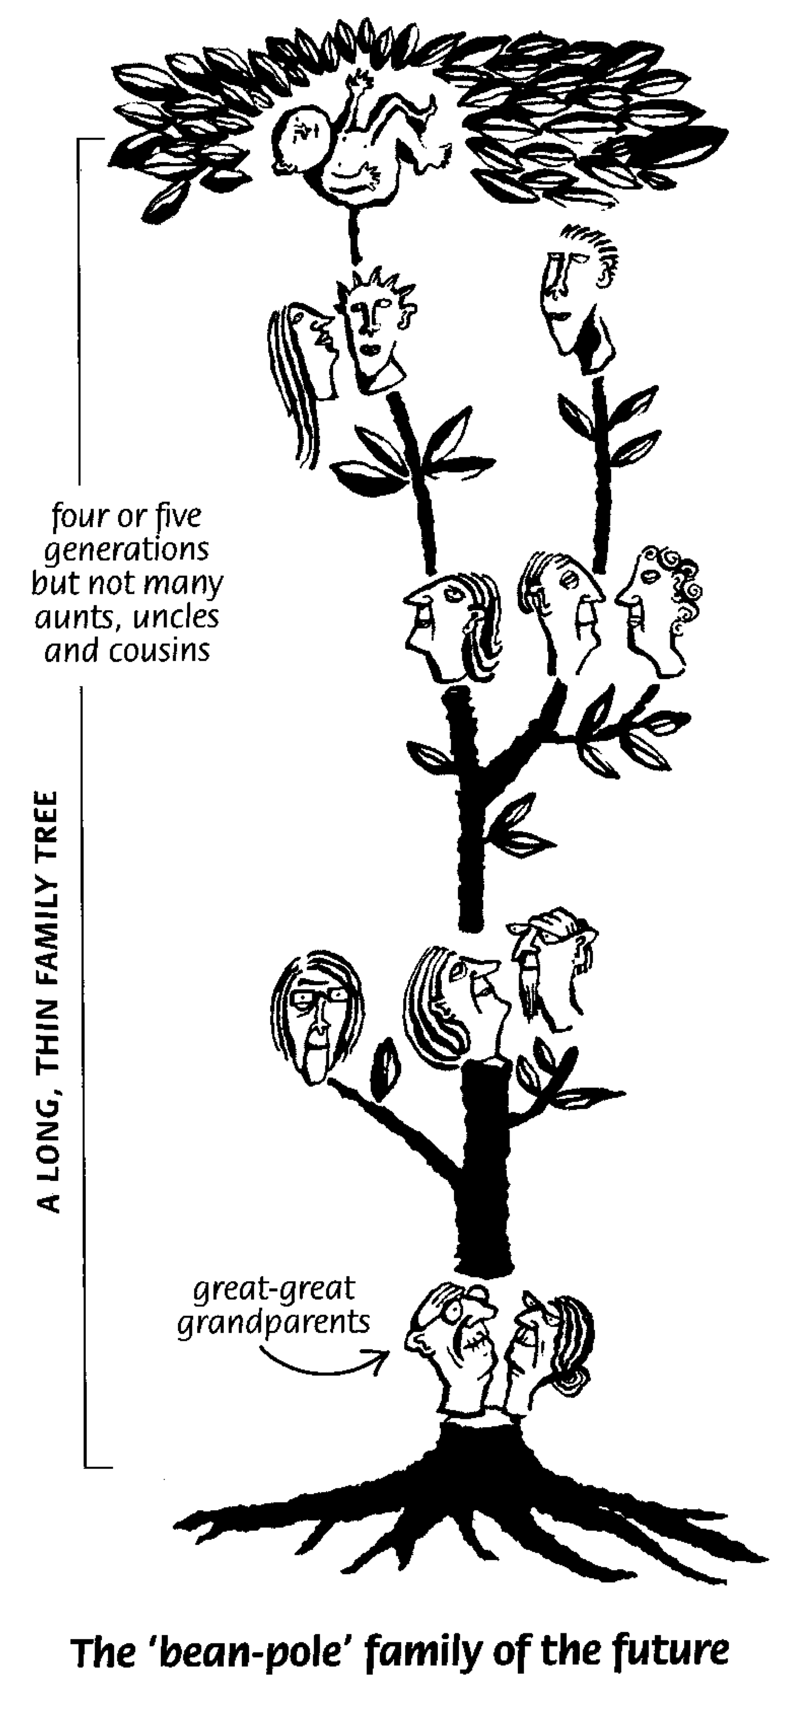

Adapted from “Natural English” by Oxford University Press

