Lesson 6, 8th Nov 2013
Grammar revision
1. Complete the sentences with the verbs in brackets in the right form
a) When I was a child, I _________________________ (use – watch) cartoons on TV1 at 7 p.m. every day.
b) I don’t know exactly what my sister ____________________ (do) now, but I think she ________________ (read) a book.
c) I _____________________ (have) breakfast yesterday at 8 in the morning.
d) Where ________________ you ___________________ (use – live) when you were a teenager?

How to ask questions in English

2. Write the questions for the following answers.
1. A: __________________________ B: Hodja was walking absent-mindedly.
2. A: __________________________ B: People had to wear a suit and a tie to work 20 years ago
3. A:__________________________ B: No, I don’t have to call my boss by her title.
4. A: __________________________ B: In my free time I like watching TV.
5. A: __________________________ B: They were playing video games in their room.
6. A: __________________________ B: I went to the drugstore for some aspirin.

Past continuous
What were you doing when the accident happened?
I was waiting for a bus when the accident happened.
I wasn’t sleeping when you called.

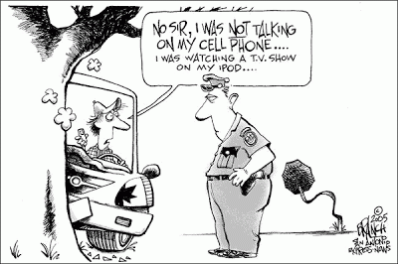
(source: http://watchmyplace.blogspot.com)

Read the following story. Then answer questions about it.

(source: www.englishexercises.org)

Hannah met Jamie in the summer of 2004. It was Hannah’s 21st birthday and she and her friends went to a club. They wanted to dance, but they didn’t like the music so Hannah went to speak to the DJ. “This music is awful, she said. Could you play something else?” The DJ looked at her and said: “Don’t worry; I have the perfect song for you.”
Two minutes later he said: “The next song is by Coldplay. It’s called Yellow and it’s for a beautiful girl who is dancing over there.” Hannah knew that the song was for her because she was wearing a yellow dress. When Hannah and her friends left the club the DJ was waiting at the door. “Hi, I’m Jamie,” he said to Hannah. “Can I see you again?” So Hannah gave him her phone number.
Next day Jamie phoned Hannah and invited her to dinner. He took her to a very romantic French restaurant and they talked all evening. After that Jamie and Hannah saw each other every day. Every evening when Hannah finished work, they met at 5.30 in a coffee bar in the High Street. They were madly in love.
One evening in October, Hannah was at work. As usual, she was going to meet Jamie at 5.30. It was dark and it was raining. She looked at her watch. It was 5.20! She was going to be late! She ran to her car and got in. At 5.25 she was driving along the High Street. She was going very fast because she was in a hurry.
Suddenly, a man ran across the road. He was wearing a dark coat so Hannah didn’t see him until it was too late. Although she tried to stop, she hit the man. Hannah panicked. She didn’t stop and drove to the coffee bar as fast as she could. But when she arrived Jamie wasn’t there. She phoned him, but his mobile was turned off, so she waited for ten minutes and then went home.
Two hours later a police car arrived at Hannah’s house. A policewoman knocked at the door. “Good evening, Madam”, she said, “Are you Hannah Davis? I’d like to speak to you. Can I come in?”.

Answer the questions about the text:

1. Where did Hannah meet Jamie? _______________________________________
2. What was Jamie doing when they met? _______________________________________
3. Where did they go on their first date? _______________________________________
4. Why did Hannah run to her car one October evening? _______________________________________
5. What did she do after she hit the man? _______________________________________
6. How long did she wait for Jamie? _______________________________________

What did the police tell Hannah? Write an ending to the story.

