Lesson 8
22nd November 2013
Adapted from Natural English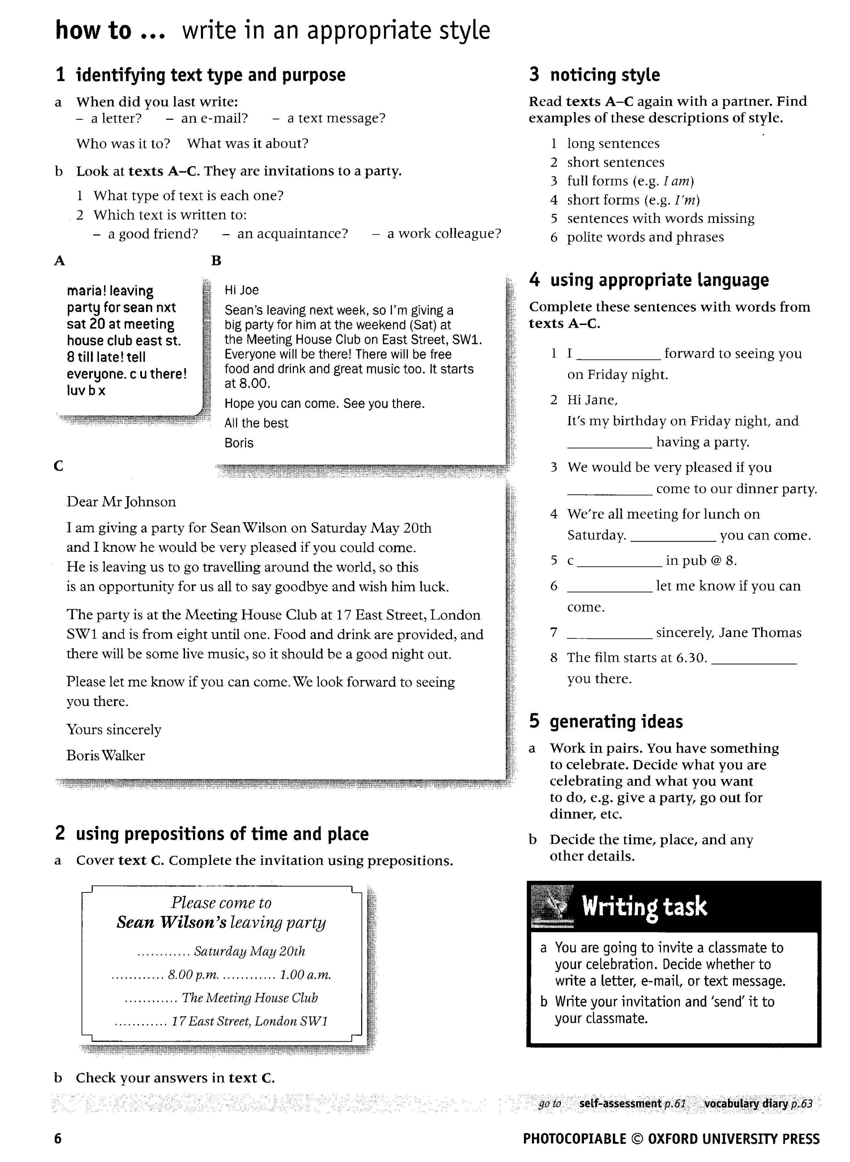
Homework: Invite me to a meeting of our English group in a pub

Adapted from: http://www.theguardian.com

My house is yours
Exchanging the keys to your own home can be a risky prospect. But as two swappers explain, it's also a great way to experience a city

- Dorothy Savage
Lives in a ninth-floor, two-bed apartment in upper Manhattan, New York. Swapped to a smaller 11th-floor apartment in Paris
This was my first house swap. Not all the proposals suit me, of course, but Danielle's offer looked just fine. She's a professor and, although her flat was a little smaller than mine, the prospect of staying a fortnight in the heart of Paris for nothing was exciting.
For two glorious August weeks we ate breakfast and a light supper every day at the apartment. It was so much better than the best hotel! What made it extra special was the fact that Danielle had stayed to welcome us before leaving to New York with her daughter. That made us feel right at home, especially as she introduced me to her friend across the hall who helped us when there was a little problem with the plumbing. Danielle was already an experienced house-swapper, so she knew the best things to do to make sure the swap went well. The website's written agreement is helpful too, and, of course, because you are living in each other's apartments at the same time, you both are motivated to keep the other place clean.

Daniele Abecassis
Swapped her Paris flat with Dorothy's New York apartment
This was my second time in Manhattan with my daughter. We stayed on 125th Street in Harlem, which is a real melting-pot. We lived in a neighbourhood with black people and with Mexicans. It was good to meet people on the street and talk for five minutes and live the way New York people live.
I have a lot of very happy memories of the city, of visiting Staten Island on the ferry, walking over Brooklyn Bridge or going to Times Square in the evenings. The city had a good vibration.
My first house swap was seven years ago and I have swapped with people all over Europe, in Ireland, France, Austria and Spain. I have had six or seven visits to my flat, which is in the centre of Paris. It's not big, only 50 square metres, but it is very, very central. By Metro, you can get anywhere - the Eiffel Tower, Notre Dame - in five to 20 minutes.
When I prepare my flat for a house swap, everything must be perfect. I leave everything out, my computer, my telephone. I want people to feel as if they are in their own home so they have internet access and use of the telephone. I leave shampoo in the bathroom and drinks in the fridge so people feel good about being there.
But not everyone can do it. It takes time and energy. There's the cleaning but also the precautions. It can take between five and six months for me to organise a house swap. I have a method now. When I contact a person, I want to get to know them, because they are going to be living in my home. I want to be sure the person lives where they say they live so I ask for a copy of their passport and proof of their address. So many people are naive and don't take precautions, but I have a contract that I send out, which has to be signed. If it doesn't come back, you know the people aren't serious.
I don't like to stay in hotels any more. If I rent a hotel room, I am a tourist. I prefer to exchange flats, because that way, not only can you travel two or three times a year, but you can live in exactly the same way as a person from a different country. In Manhattan, I had the same habitat. I was an American for a month and that's the way I like to travel.

