Lesson 10
6th December 2013

The real Saint Nicholas
True or false?
- The real Saint Nicholas was French.
- He was a king.
- He lived in the 3rd and 4th centuries AD.
- He was rich, because he earned fortune playing cards.
- He helped the poor but didn’t want anybody to know about it.
- He is one of the few common saints in the Orthodox and Catholic Churches.

(adapted from: http://www.stnicholascenter.org)
The real Saint Nicholas lived a long time ago in a place called Asia Minor. It is now the country of Turkey. His name was Nicholas.
Nicholas' parents died when he was just a teenager. They left him a lot of money that made him a rich young man. He went to live with his uncle who was a priest.
Nicholas heard about a man who had lost all his money. He had three daughters who were old enough to get married. But in those days, young women had to have money in order to get married. This money was a "dowry" and it was used to help the new family get started. If you didn't have dowry money, you didn't get married.
This family was so poor they had nothing left to eat. The daughters were going to be sold as slaves because they couldn't live at home any longer. They were very sad. They wouldn't be able to have families of their own. And they would have to be slaves—no longer able to decide where they would live or what they would do.
The night before the oldest daughter was to be sold, she washed her stockings and put them in front of the fire to dry. Then all of them went to sleep—the father and the three daughters.
In the morning the daughter saw a lump in her stocking. Reaching in, she found a small, heavy bag. It had gold inside! Enough to provide food for the family and money for her dowry. Oh, how happy they were!
The next morning, another bag with gold was found. Imagine! Two of the daughters would now be saved. Such joy!
And the next night, the father planned to stay awake to find out who was helping his daughters. He dozed off, but heard a small "clink" as another bag landed in the room. Quickly he jumped up and ran out the door. Who did he catch ducking around the corner?
Nicholas, the young man who lived with his uncle. "Nicholas, it is you! Thank you for helping us—I hardly know what to say!" Nicholas said, "Please, do not thank me—thank God that your prayers have been answered. Do not tell others about me."
Nicholas continued helping people. He always tried to help secretly. He didn't want any attention or thanks. Years passed and he was chosen to be a bishop. Bishops look after their people as shepherds look after their sheep. And that is what Nicholas did. When there wasn't any food, he found wheat; so no one went hungry. He always helped people in trouble. All his life Nicholas showed people how to love God and care for each other.
Everyone loved Nicholas. After he died, they told stories of the good and kind things Nicholas had done. Sailors took these stories about Nicholas everywhere they went. Some of the stories were about his special care for children—helping and protecting them when danger threatened. And so more and more people learned about good, kind Nicholas. They wanted to be like him. He is an example of how we should live. And that is why he became a Saint.
This is the story of the real Santa Claus, St. Nicholas. To this day people say that St. Nicholas, or Santa, is the special friend of children.

(adapted from: http://www.biography.com)

QUICK FACTS

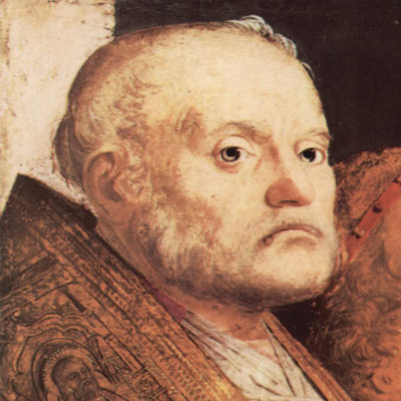

- NAME: St. Nicholas
- OCCUPATION: Saint
- BIRTH DATE: c. 280
- DEATH DATE: December 06, 343
- PLACE OF BIRTH: Patara, Turkey
- PLACE OF DEATH: Myra, Turkey
- FULL NAME: St. Nicholas of Myrna
- AKA: Saint Nick
- AKA: St. Nicholas
- AKA: St. Nick
- AKA: Nikolaos of Myra
AKA: St. Nicholas of Myra

What is your attitude to presents?

- When did you stop believing in Santa Claus?
- Do you tend to give presents that are practical or pretty?
- When do you start looking for and buying presents? A month/week/day before the event?
- Do you ever order presents online?
- Are you good at coming up with ideas for presents?
- Who is the worst person to find a present for?
- Do you think a gift voucher is a good present?
- Do you remember the first present you have ever given to someone?
- What do you say when you don’t like a present someone gave you?

