Lesson 14 17th January 2012

*1. In pairs, ask each other these questions about eating habits*



*Adapted from: English Result*

*2. Match the cooking verbs from the box with their definitions below*

|  |
| --- |
| barbecue boil chop fry grill heat peel pour roast stir wash |

1. Cook food on or under a high heat.
2. Clean something in water.
3. Make water very hot.
4. Make food hot.
5. Cut the skin off fruit and vegetables.
6. Cut food into pieces.
7. Use a spoon to move the food around the pot.
8. Cook food over a fire or in an oven.
9. Cook food in hot oil.
10. Put drinks into cups or glasses.
11. Cook on a frame over a fire.

*3. Look at the chart below. Is your plate a healthy one?*

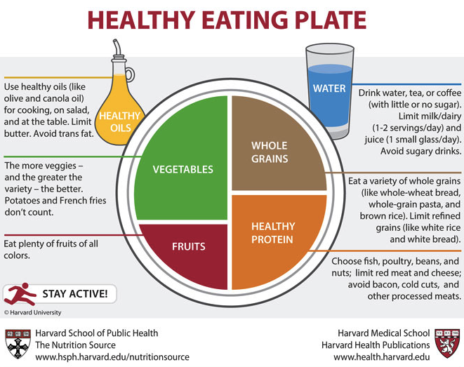

*4. Put the recipe in order*

Delicious beef and vegetable kebabs

You will need some … beef, olive oil, yellow and green peppers, onions, tomatoes, herbs, garlic, pepper

____ After that, chop some yellow and green peppers.

____ Then cut the beef into square pieces and put into the bowl with the oil mix. Leave it for two hours.

____ Grill the kebabs for 10-15 minutes, turning them until the meat is brown on all sides.

____ Next, prepare the vegetables. First, peel a few onions and chop them into big pieces.

____ Finally, serve the kebabs with a little salad and a cold drink!

____ Then pour a little of the oil mix over the kebabs.

____ First of all, put some olive oil, a few herbs, and a little garlic into a bowl and stir it. Add some lemon juice and a little pepper.

____ Now, you’re ready to make the kebabs. Put the meat and chopped vegetables onto a skewer with some small tomatoes.

*In the recipe, underline phrases that refer to the quantity of ingredients.*

*And now, write your own favourite recipe ☺*