Lesson 8 20 November 2014

*(adapted from English Result Pre-Intermediate)*

***Free time***

***1.***

|  |  |
| --- | --- |
|  |  |
|  |  |

***2.***

|  |  |
| --- | --- |
|  |  |

***3.***

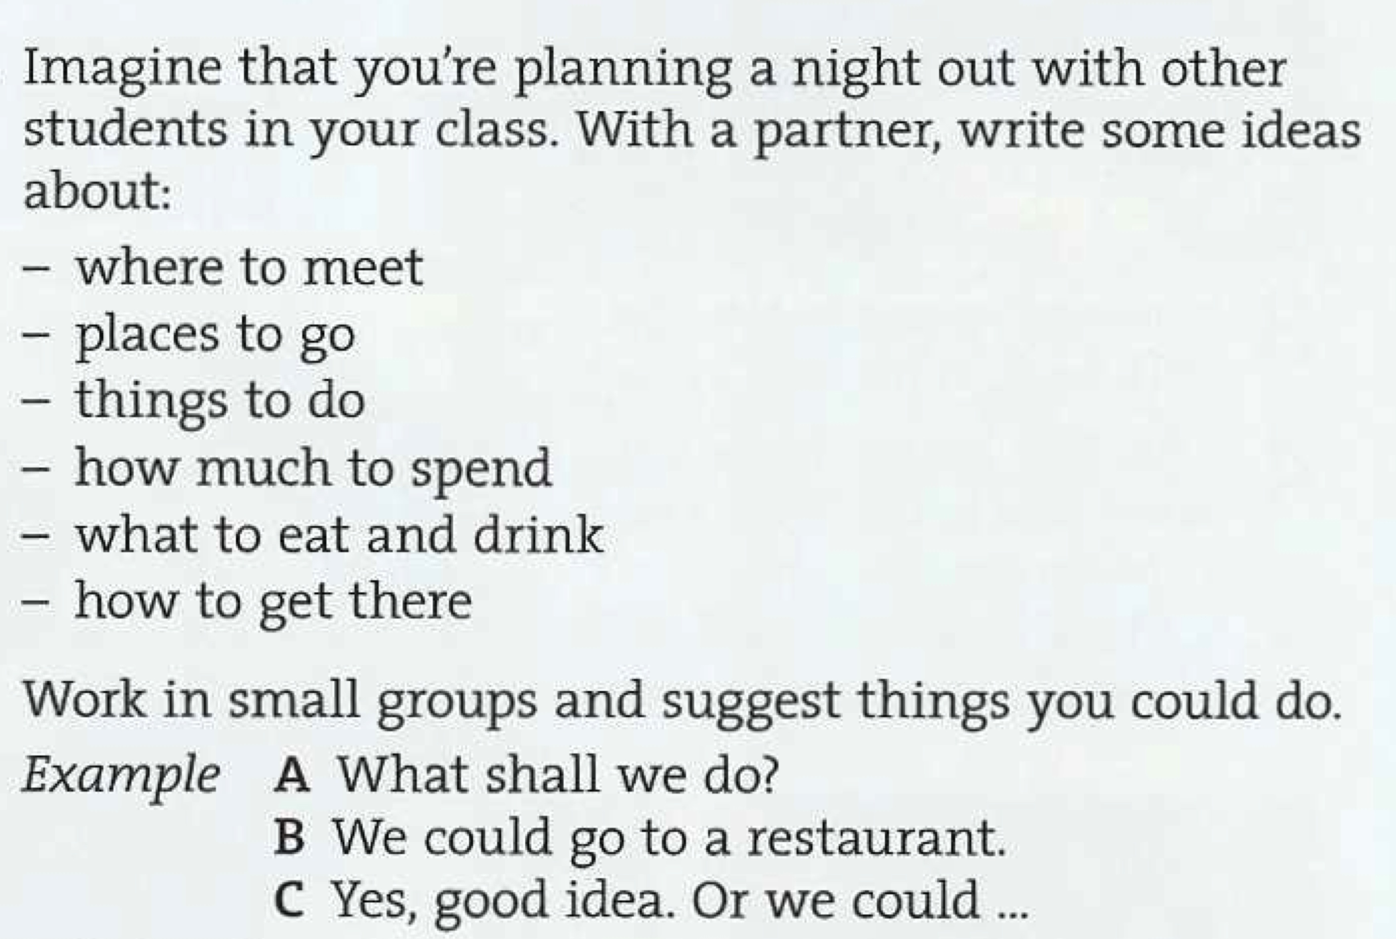

***4.***

|  |  |
| --- | --- |
|  |  |