Lesson 11 18 December 2014

JOBS

(adapted from English Result Intermediate)

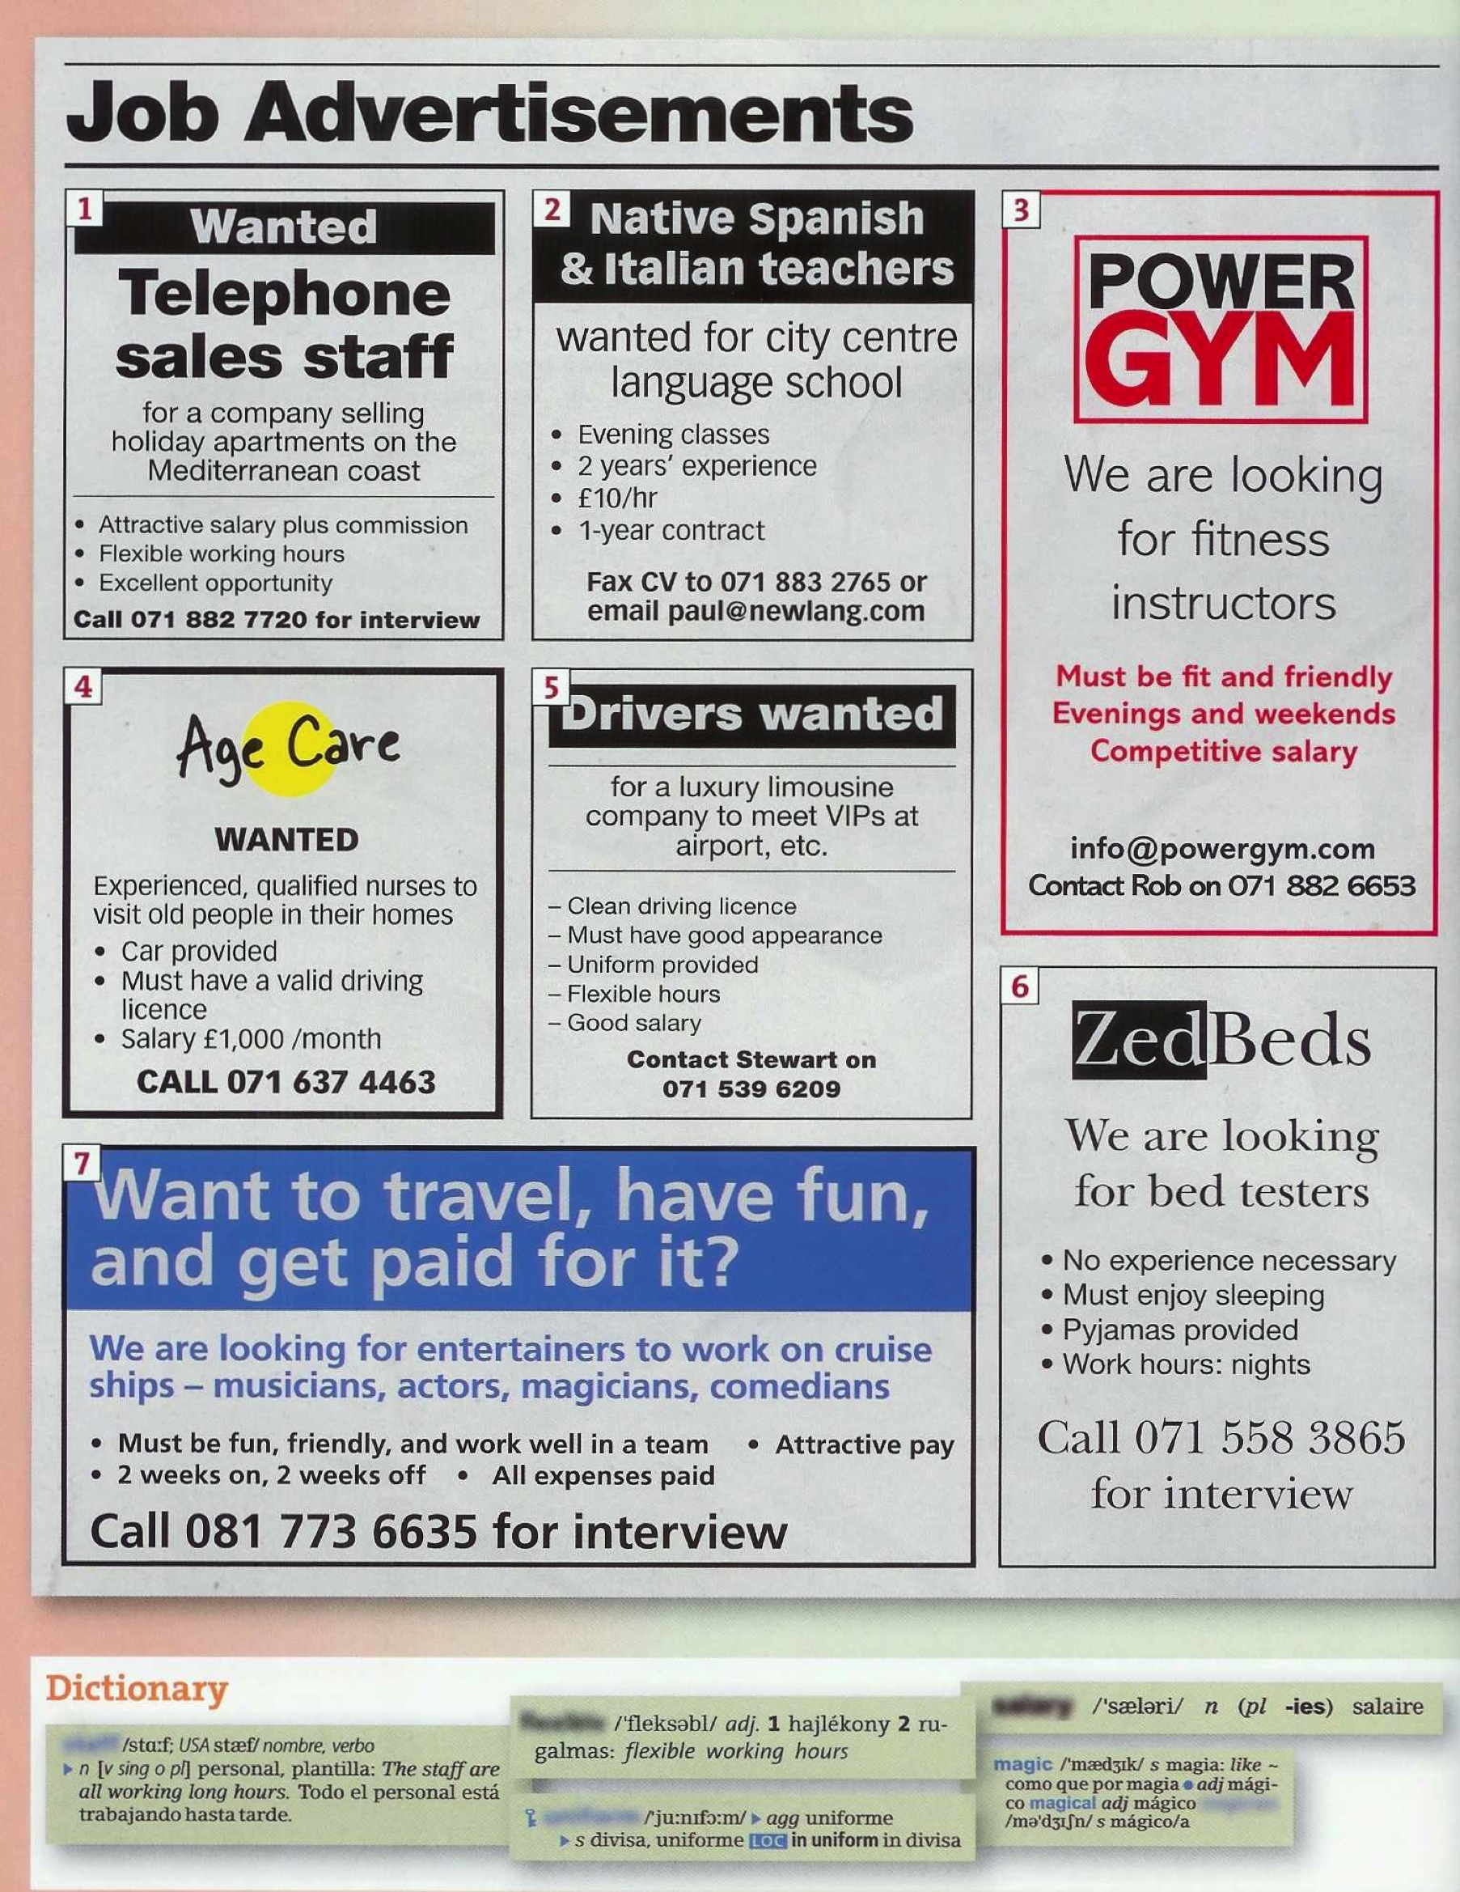

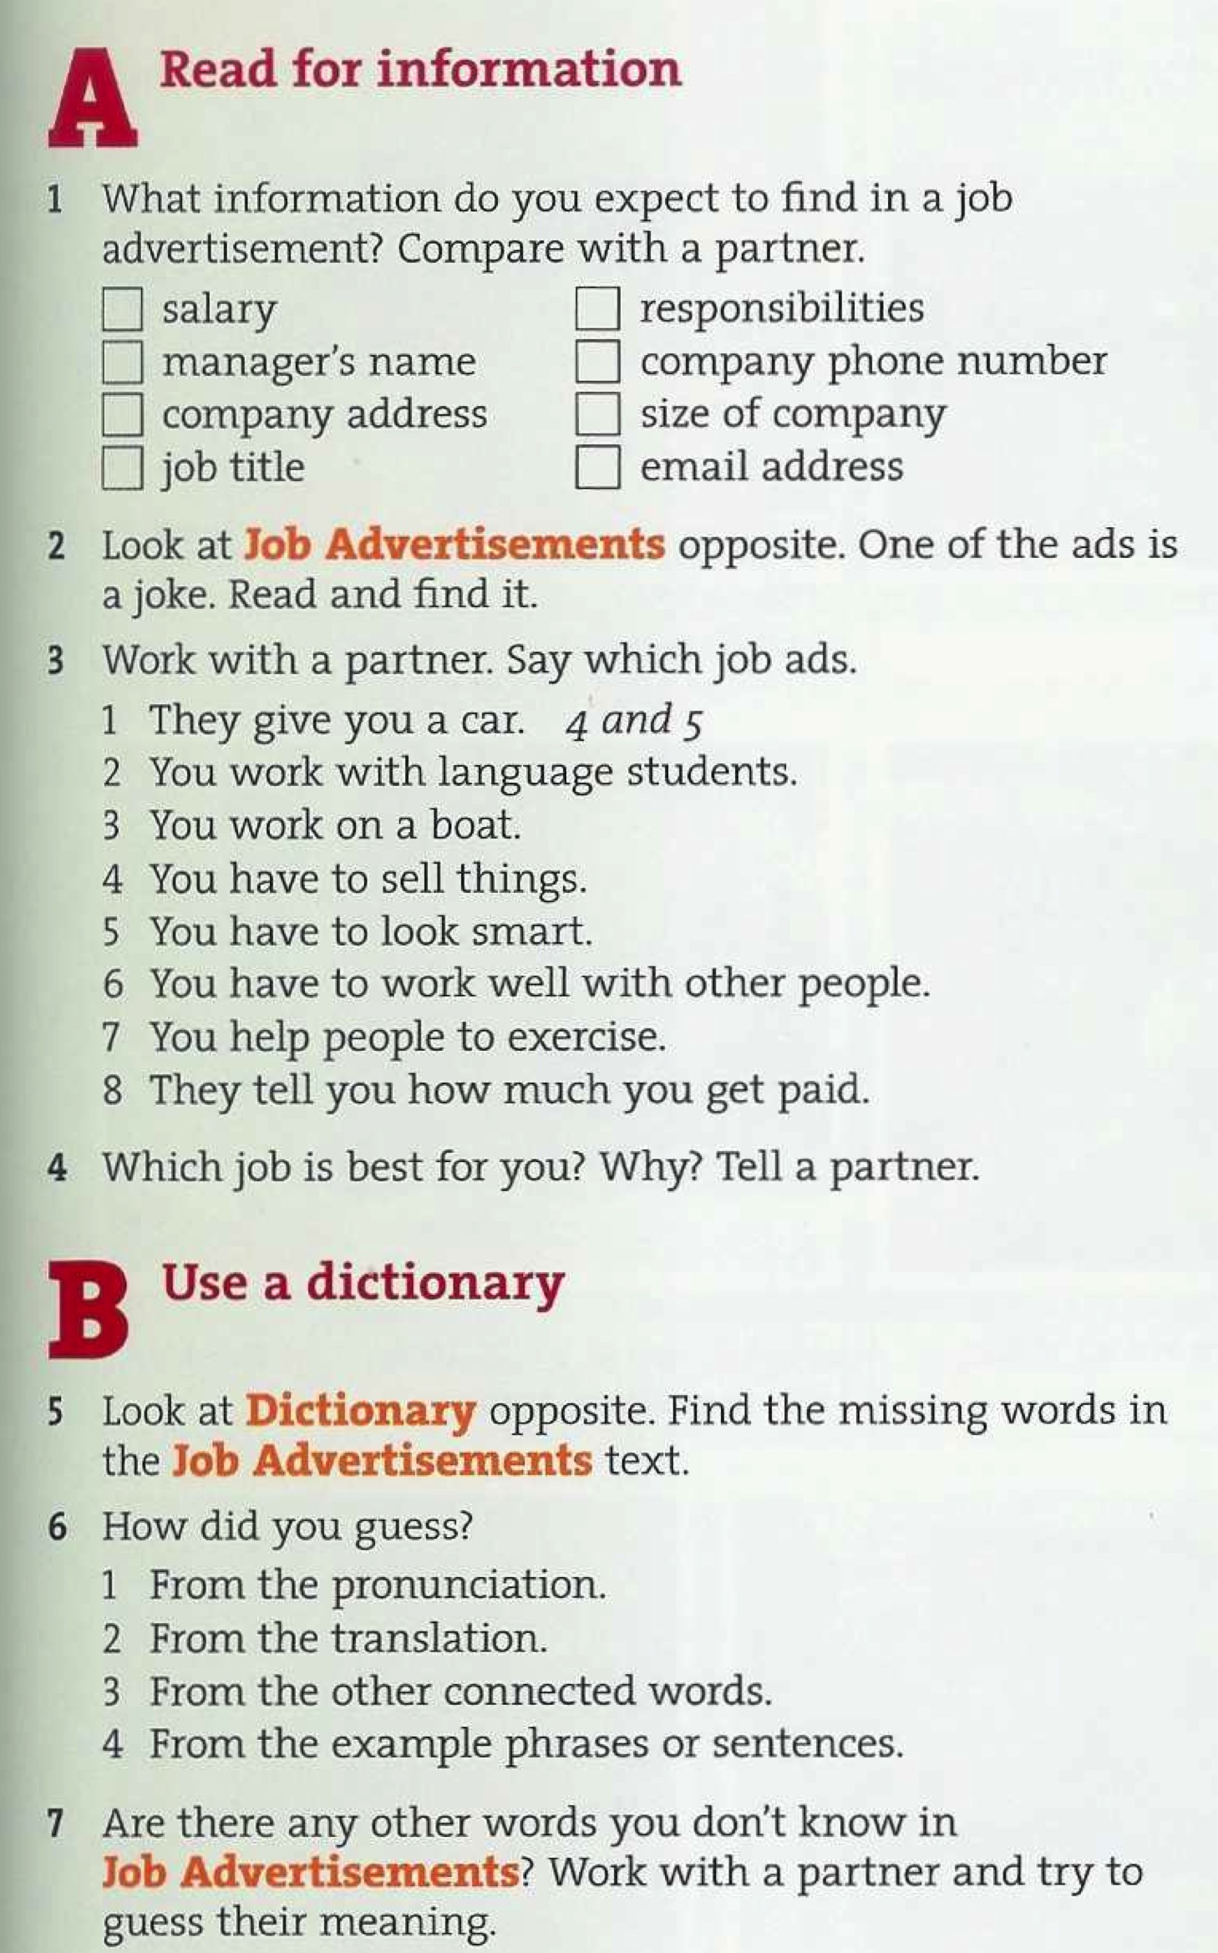

CHRISTMAS
Answer the questions: Yes, I do. / No, I don’t.
- Do you like buying presents?
- Do you like getting presents?
- Do you like sending Christmas cards?
- Do you like getting Christmas cards?
- Do you like cleaning the house before Christmas?
- Do you like cleaning the house after Christmas?
- Do you like baking cakes?
- Do you like eating cakes?
- Do you like dressing the Christmas tree?
- Do you like singing Christmas songs?

