Lesson 10 4 December 2014

Phone calls

(adapted from English Result Pre-Intermediate)

1. Paola phones the college. Listen and say how many phone calls she makes.
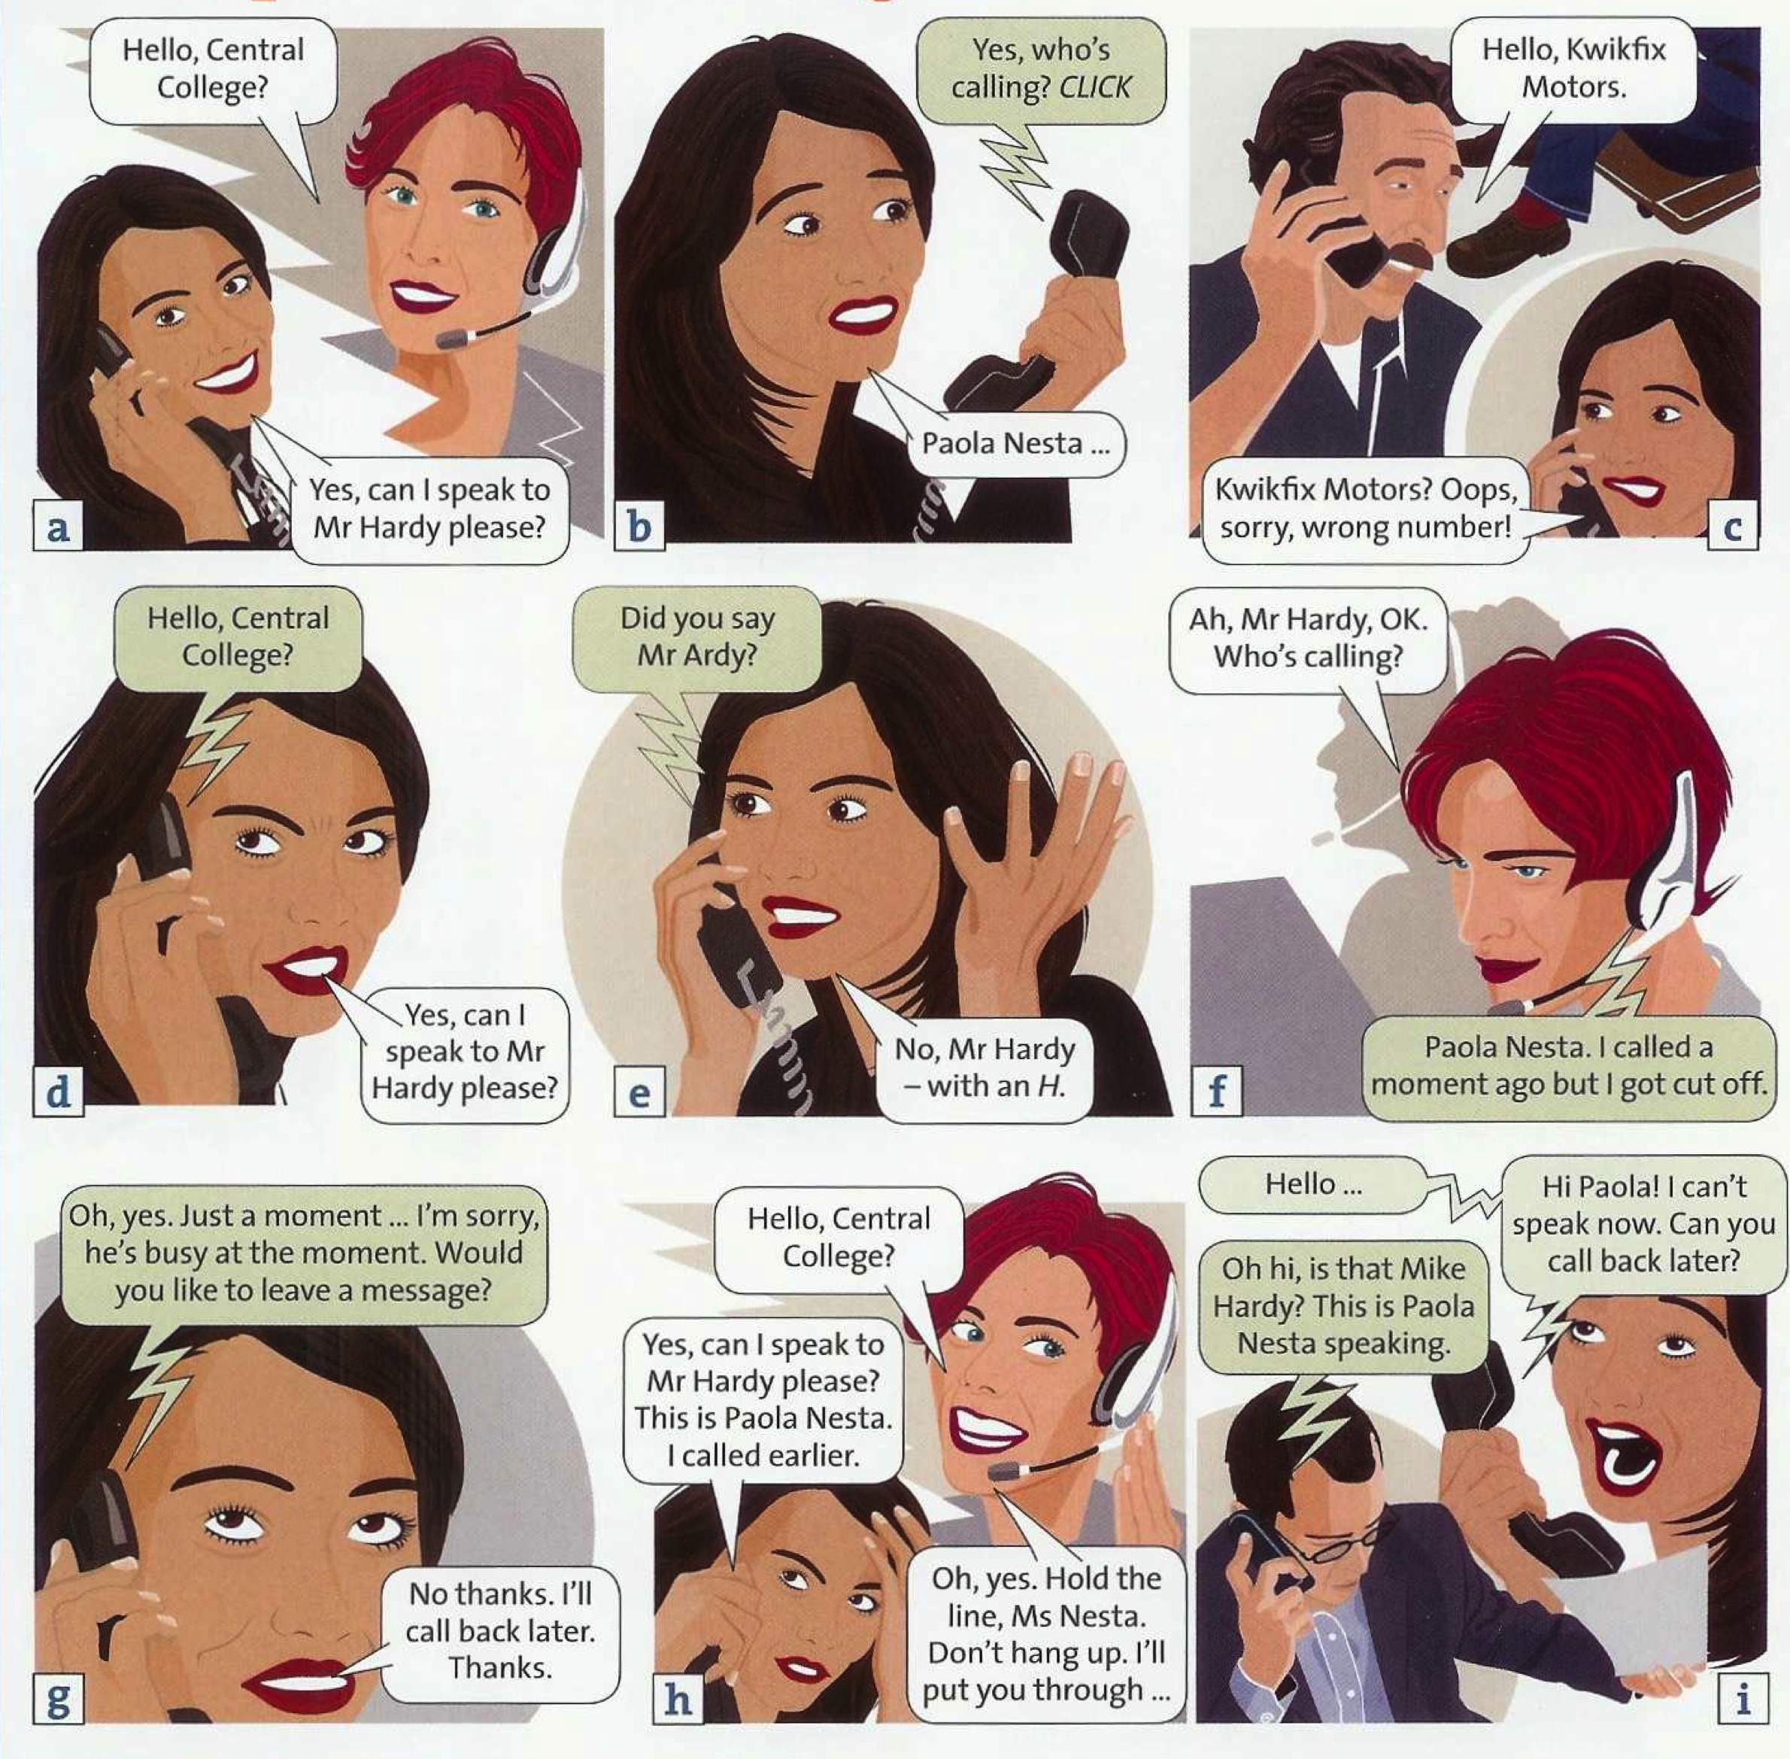

2. Read the conversations again and answer the questions:
- What three problems does Paola have?
- Where does Mr Hardy work?
- Does Mr Hardy know Paola?

3. Complete the telephone phrases:
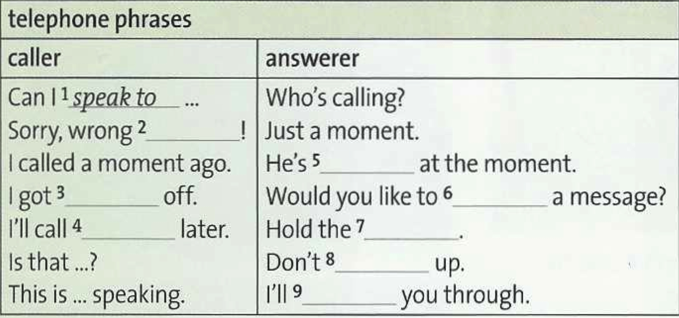

- Complete the automated message with the phrases from the table above

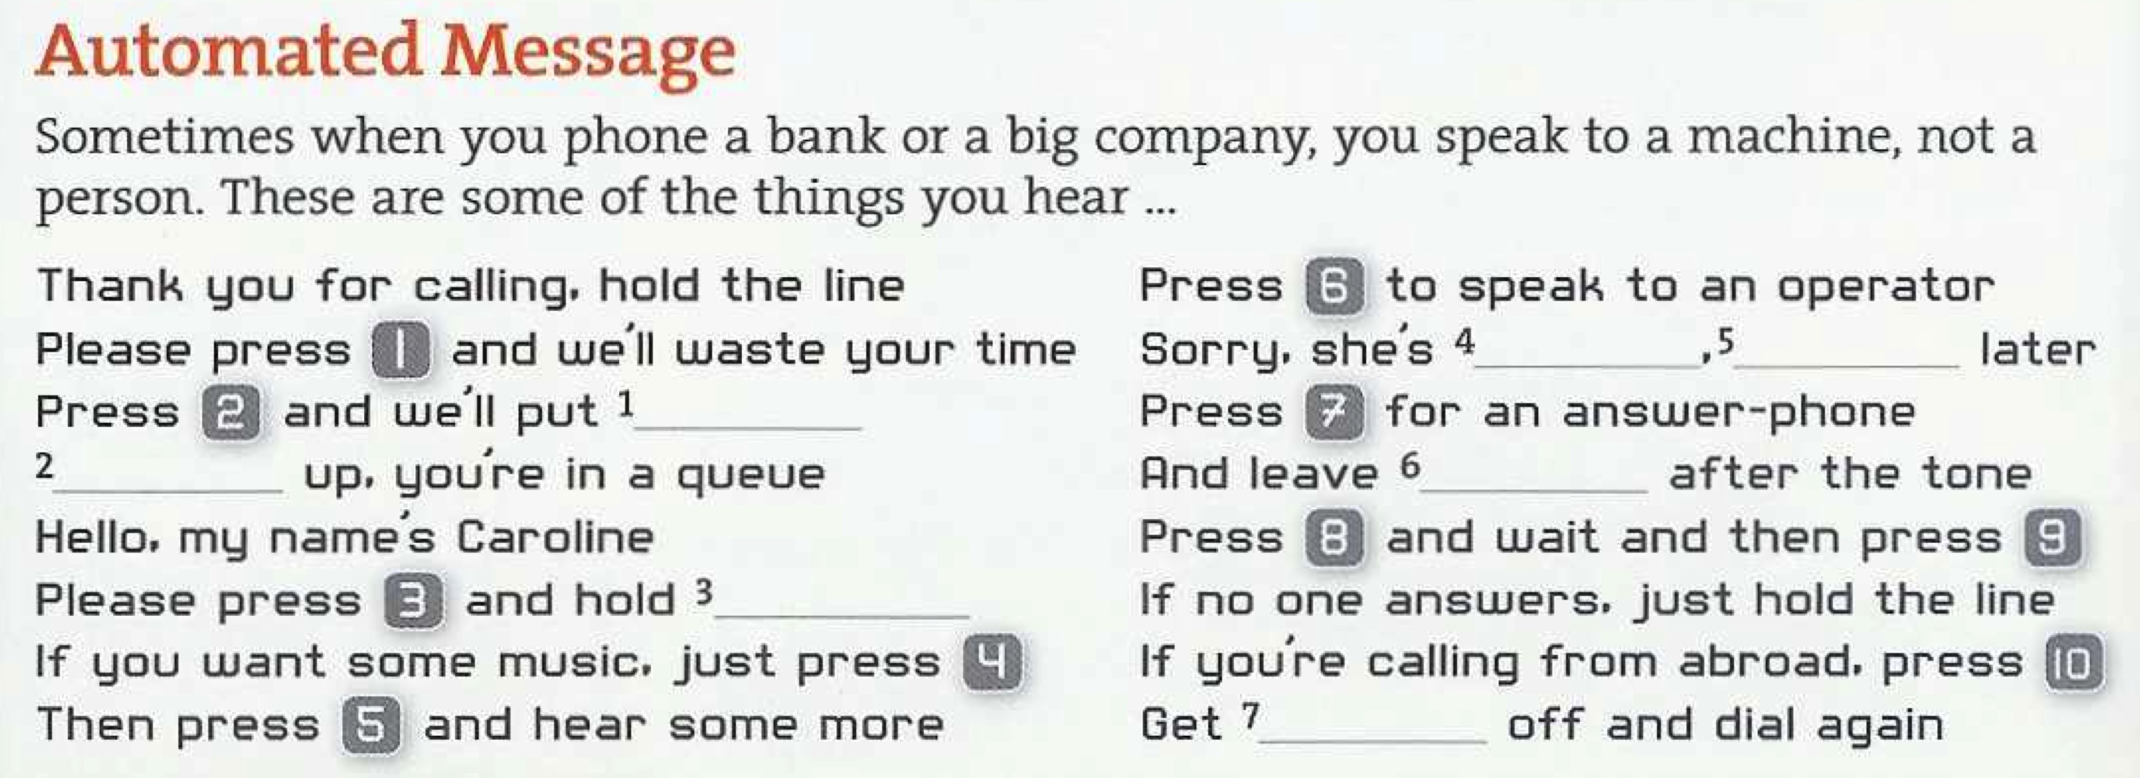

5. Which words from the Automated Message mean the following:
1. A line of people who are waiting ________________
2. A telephonist ___________
3. A machine that takes messages ________________
4. The sound you hear before leaving a message ________________
5. In a foreign country ________________
6. Push buttons to call a phone number _______________

6. Are these sentences from a person (P) or an automated message on a machine (M)?
