Lesson 4 22 October 2014

Revision – family members
- Write the missing vowels. Who are these people? Explain in English
- st__p f__th__r
- g__d m__th__r
- f__ __nc__
- n__ __c__
- gr__ __t gr__ndd__ __ght__r
Me and my best friend

- Compare you and your best friend.

- _______________________________________________________________? / _________________________________________________________________?

My name is _________________________. / His/Her name is ______________________.

- _______________________________________________________________? / _________________________________________________________________?

I live in _________________________. / He/She lives in _________________________.

- _______________________________________________________________? / _________________________________________________________________?

My eyes are _________________________. / His / Her eyes are _________________________.

- _______________________________________________________________? / _________________________________________________________________?

My hobby is _________________________. / His/Her hobby is _________________________.

- _______________________________________________________________? / _________________________________________________________________?

I have got_____ brother(s) and ____ sister (s). / She/He has got_____ brother(s) and ____ sister (s).

Traveling
(Adapted from English Result Pre-Intermediate)
3. What are these documents? Write down the words. What do you need them for? Explain in English.

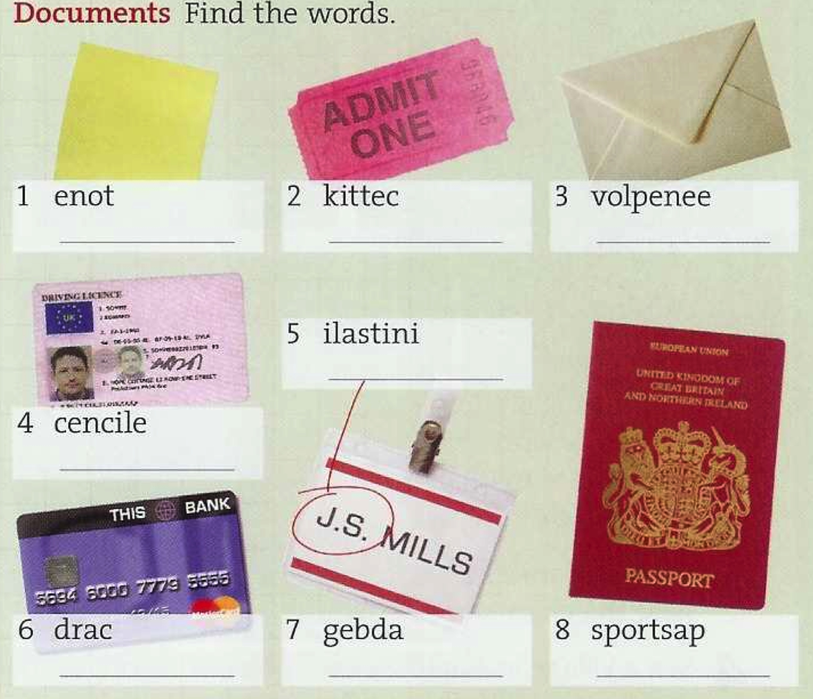

4. What kind of places can you see on the pictures? Read the descriptions below and match them with the pictures.

