Lesson 4 13 October 2014

***Likes and dislikes***

(adapted from *Natural English Intermediate*)

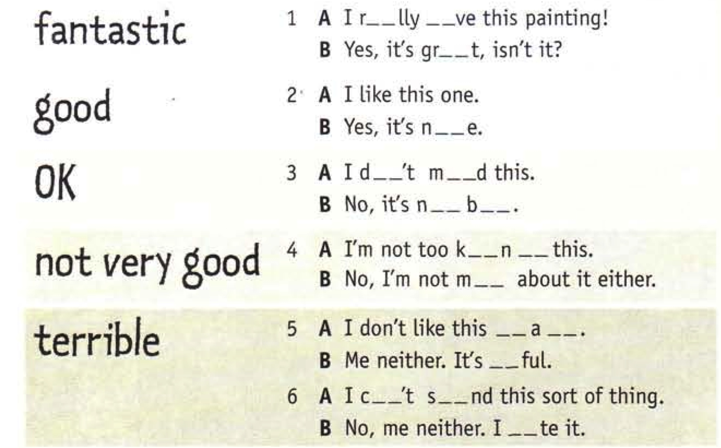

|  |  |  |
| --- | --- | --- |
|  |  |  |

***Sharing news***

(adapted from *Reading B2+ Upper Intermediate*)

