Lesson 1 25 September 2014

Talking about yourself (adapted from Recycling Elementary English)

My name is Susie. I live at 82 Hilton Street. I live in Cardiff.
I live in Wales. I come from Wales. I’m Welsh.
I’m single. I’m engaged. I’m married. I’m divorced.
I live in a flat. I live in a house.
I speak English. I speak French and German.
I’m a nurse. I’m a teacher. I’m a doctor. I’m retired.
I work in an office. I work in a shop.
I like reading. I like traveling. I like listening to music.

A. Complete each sentence with 1 or 2 words from the table.

- My _________________________ Susie.
- I _________________________ from Wales.
- I _________________________ in a house.
- I _________________________ English and French.
- I _________________________ a secretary.
- In my free time, I _________________________ reading magazines.

B. Complete the sentences with: in / at / from / to.

1. I live _________________________ Buenos Aires.
2. We live _________________________ 104 Wilbury Drive.
3. I live _________________________ Norway.
4. I come _________________________ Ireland.
5. I live _________________________ a flat.
6. I like listening _________________________ music.
7. I work _________________________ an office.

C. Complete the sentences about this man
- My name’s ________________________.
- I live at _________________________.
- I live in _________________________. It’s a city in _________________________.
- I’m _________________________.
- I live in a _________________________.
- I speak _________________________ and _________________________.
- I _________________________ in a shop.
- I _________________________ doing maths tests.
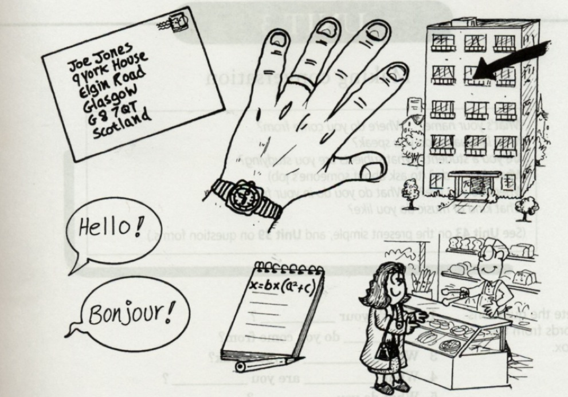
D. What about you?

What’s your name? __________________________________________________________
Where do you live? __________________________________________________________
Where do you come from? __________________________________________________________
What’s your nationality? __________________________________________________________
Where do you work? __________________________________________________________
Are you single or married? __________________________________________________________
What languages do you speak? __________________________________________________________
What do you like doing in your free time? _____________________________________________________

