Lesson 2 29 September 2014

Revision
- Complete the sentences:
- I live _________________ 25 Szkolna Street ___________________ Reda.
- I come _______________________ Poland.
- I ____________________ English and a little German.
- In my free time, I ______________________ reading books.
- I _____________________ married and I ______________________ 2 children.

Jobs
2. Put “a” or “an” before the jobs in the box

__ housewife __ engineer __ office worker __ waiter/waitress
__ lawyer __ police oficer __ businessman/woman __ shop assistant
__ actor/actress __ journalist

3. What do you do? Complete the sentences with the jobs from ex. 2.
a) I play in films. I’m ___________________________
b) I write articles. I’m ___________________________
c) I do paper work. I’m ___________________________
d) I serve people in restaurants. I’m ___________________________
e) I catch criminals. I’m ___________________________
f) I clean the house and cook. I’m ___________________________
g) I construct buildings. I’m ___________________________
h) I have my own company. I’m ___________________________
i) I help people with legal problems. I’m ___________________________
j) I sell things to people. I’m ___________________________

4. Write three words that you associate with the jobs from exercise 2.
(example: a housewife: kitchen, children, cleaning)

Numbers
(Adapted from Natural English Elementary)

5. Answer the questions
- Write down your telephone number ___________________________________
- What bus number goes from Gdynia to Reda?
- What is the lucky/unlucky number in Polish tradition?
- What is the emergency telephone number in Poland?
- When is your birthday? (My birthday is on 29 March)

6. Complete these numbers:
- 3, 6, 9, ___ , ___ .
- 15, 25, 35, ___ , ___ .
- 7, 14, 21, ___ , ___ .
- d) 70, 80, 90, ___ , ___ .
- 60, 16, 50, 15, ___ , ___ .
- 5, 15, 45, ___ , ___ .

Countries and nationalities
7. Complete the table
Country | Nationality
France | Fr__nch
Germany | G__rm__n
Japan | J__p__n__s__
Spain | Sp__n__sh
Argentina | __rg__nt__n__ __n
China | Ch__n__s__
Italy | __t__l__ __n
Brazil | Br__z__l__ __n
Poland | P__l__sh
Britain | Br__t__sh

8. True or false?

- Brigitte Bardot is Italian.
- David Beckham is British.
- Angela Merkel is Russian.
- Doda is Polish.
-
-
-
-

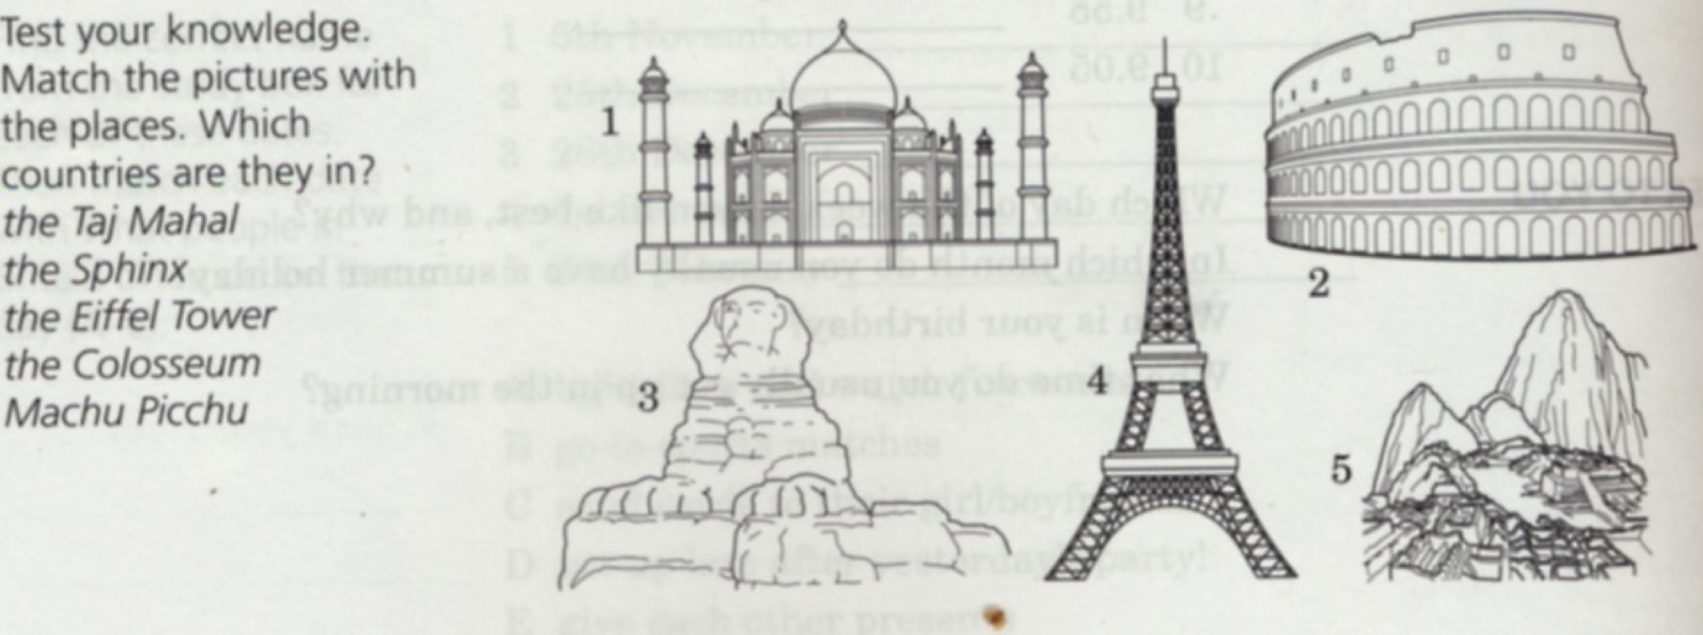

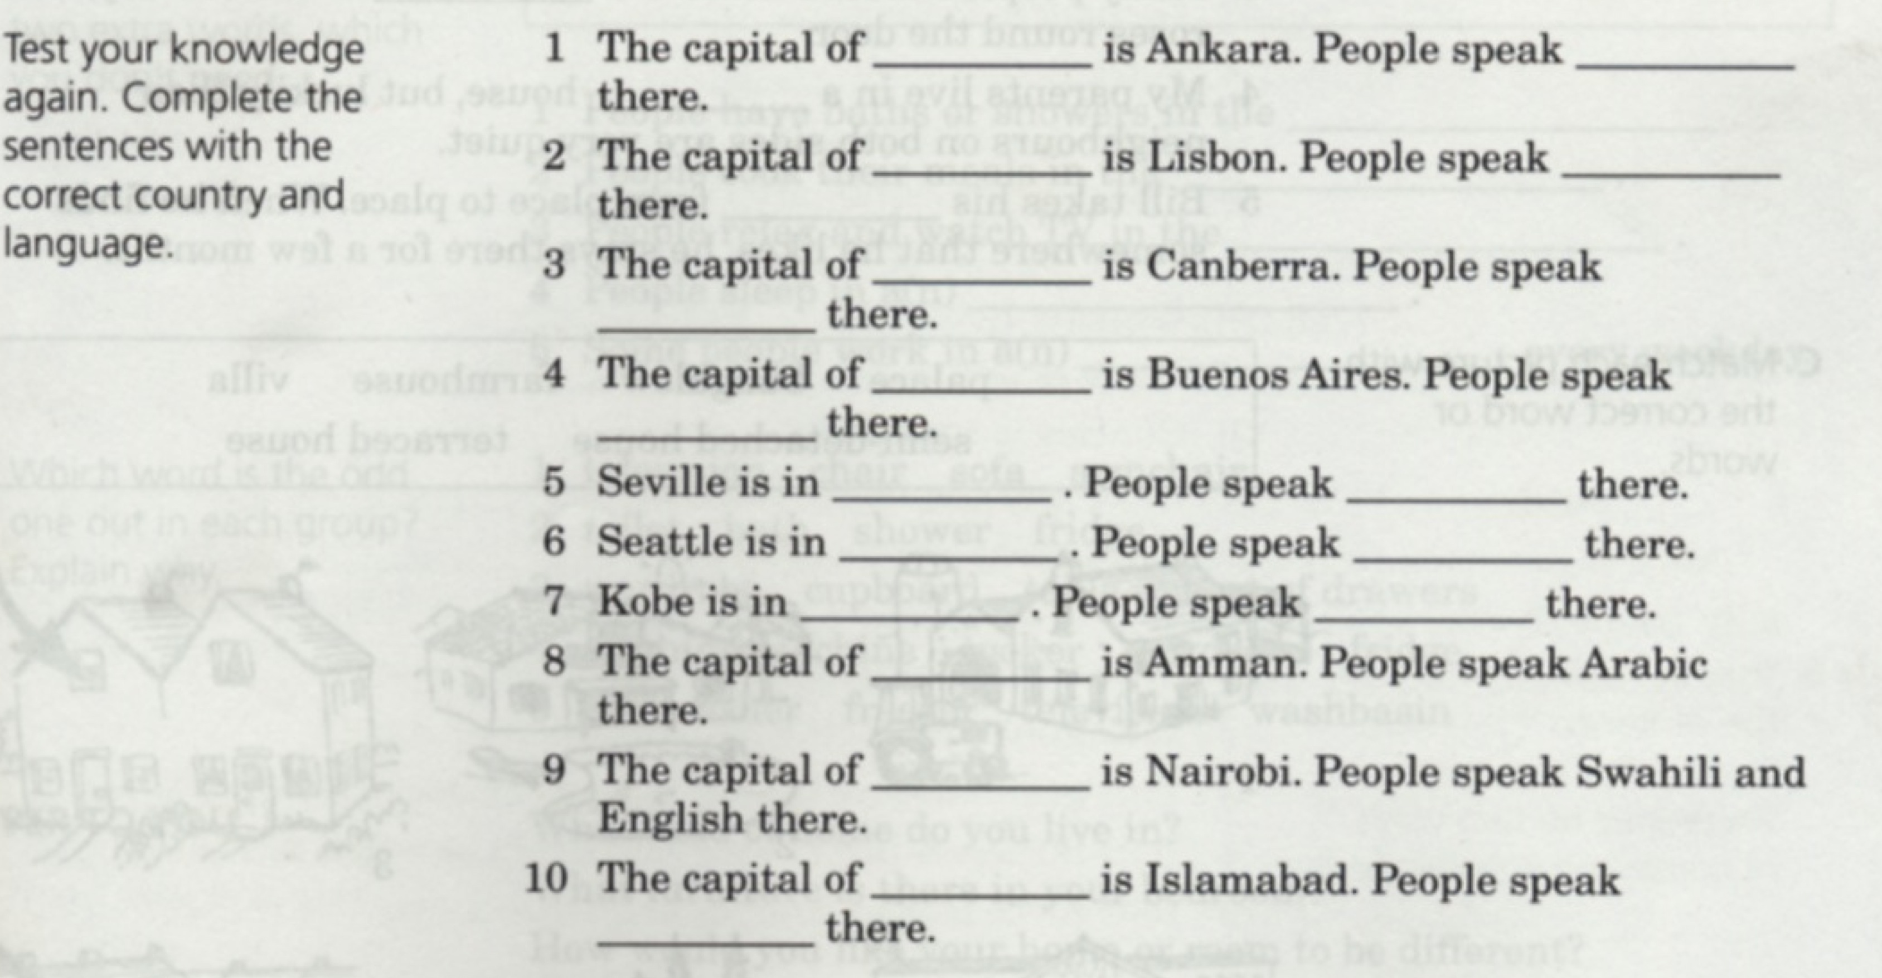
(adapted from Recycling Elementary English)

