Lesson 5 30 October 2014

- Traveling

- Write some words in each column

Means of transport | Interesting places | Activities for tourists
- train | - castle | - hiking

B. What do these phrases mean?
- round trip trip to a place / trip from a place / trip to a place and back
- return fare the price of a one way trip / the price of a round trip
- day trip a trip that lasts one day / a trip that you can take during the day, not at night

- Listen and answer the questions
(Adapted from English Result Pre-Intermediate)
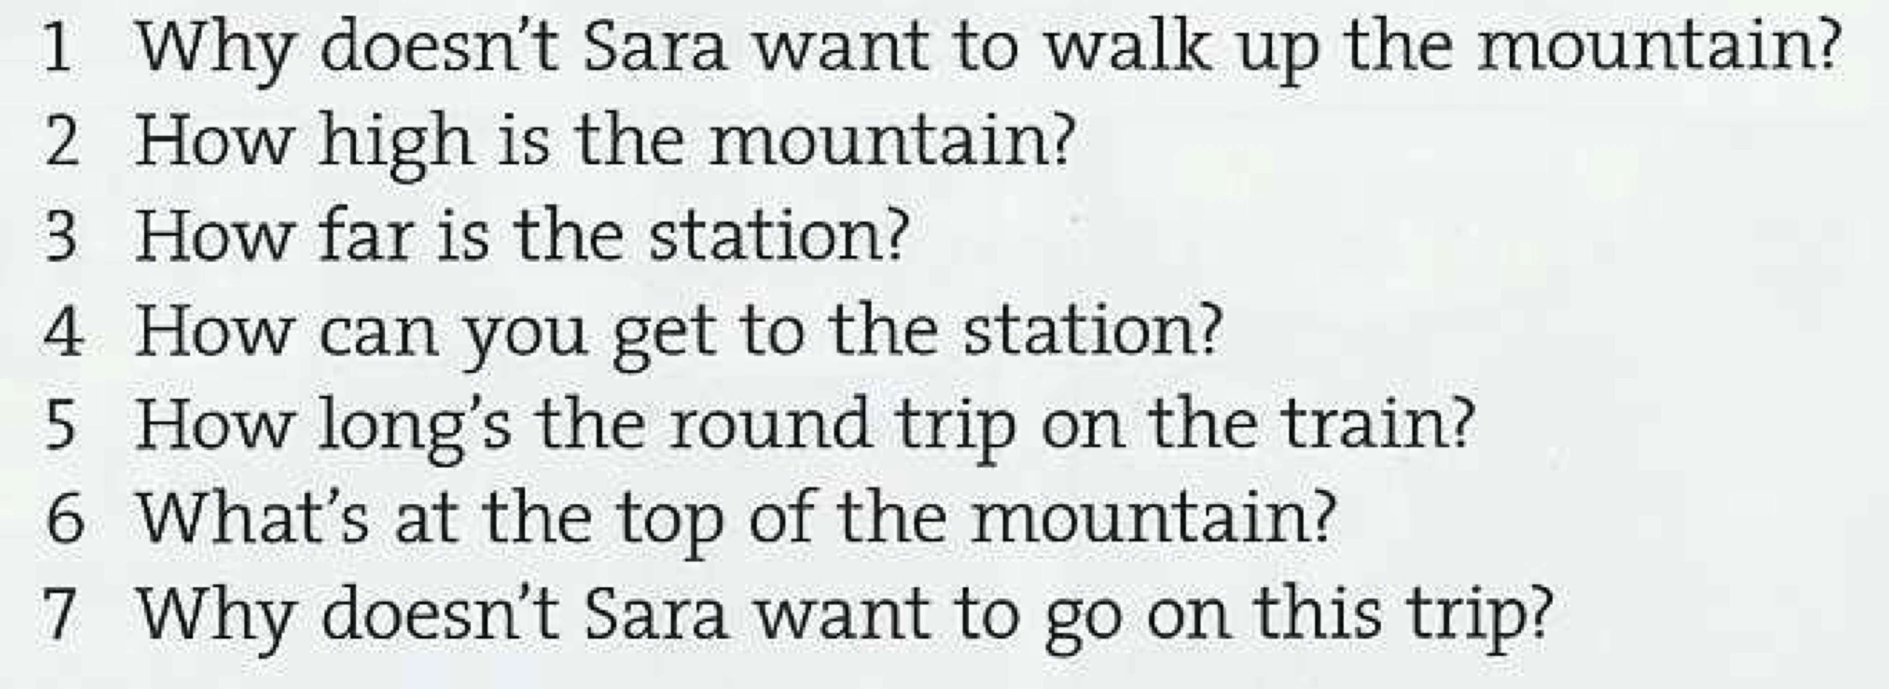

D. Do you know these places in the Tricity?
- It is an old church in Gdańsk with famous organs. It stands near a beautiful park.
- It is the longest apartment building in Europe. It is 860 m long. About 6 thousand people live there.
- It is a tower in the Gdansk Old Town. You can see amber objects there.

In pairs, write 2 descriptions of famous places in the Tricity
2. Eating out
A. In pairs, ask and answer these questions
- How often do you eat out? (often / sometimes / rarely / once a week)
- Do you have a favourite restaurant? (Yes, I do. It is…. / No, I don’t.)
- Do your prefer fast food or slow food? (I prefer ……., because ……)
- What is the best pizza restaurant in the Tricity? (In my opinion, the best ……)

(Adapted from Recycling Elementary English)
