Lesson 1 22 September 2014

Invitations – adapted from Reading Upper Intermediate

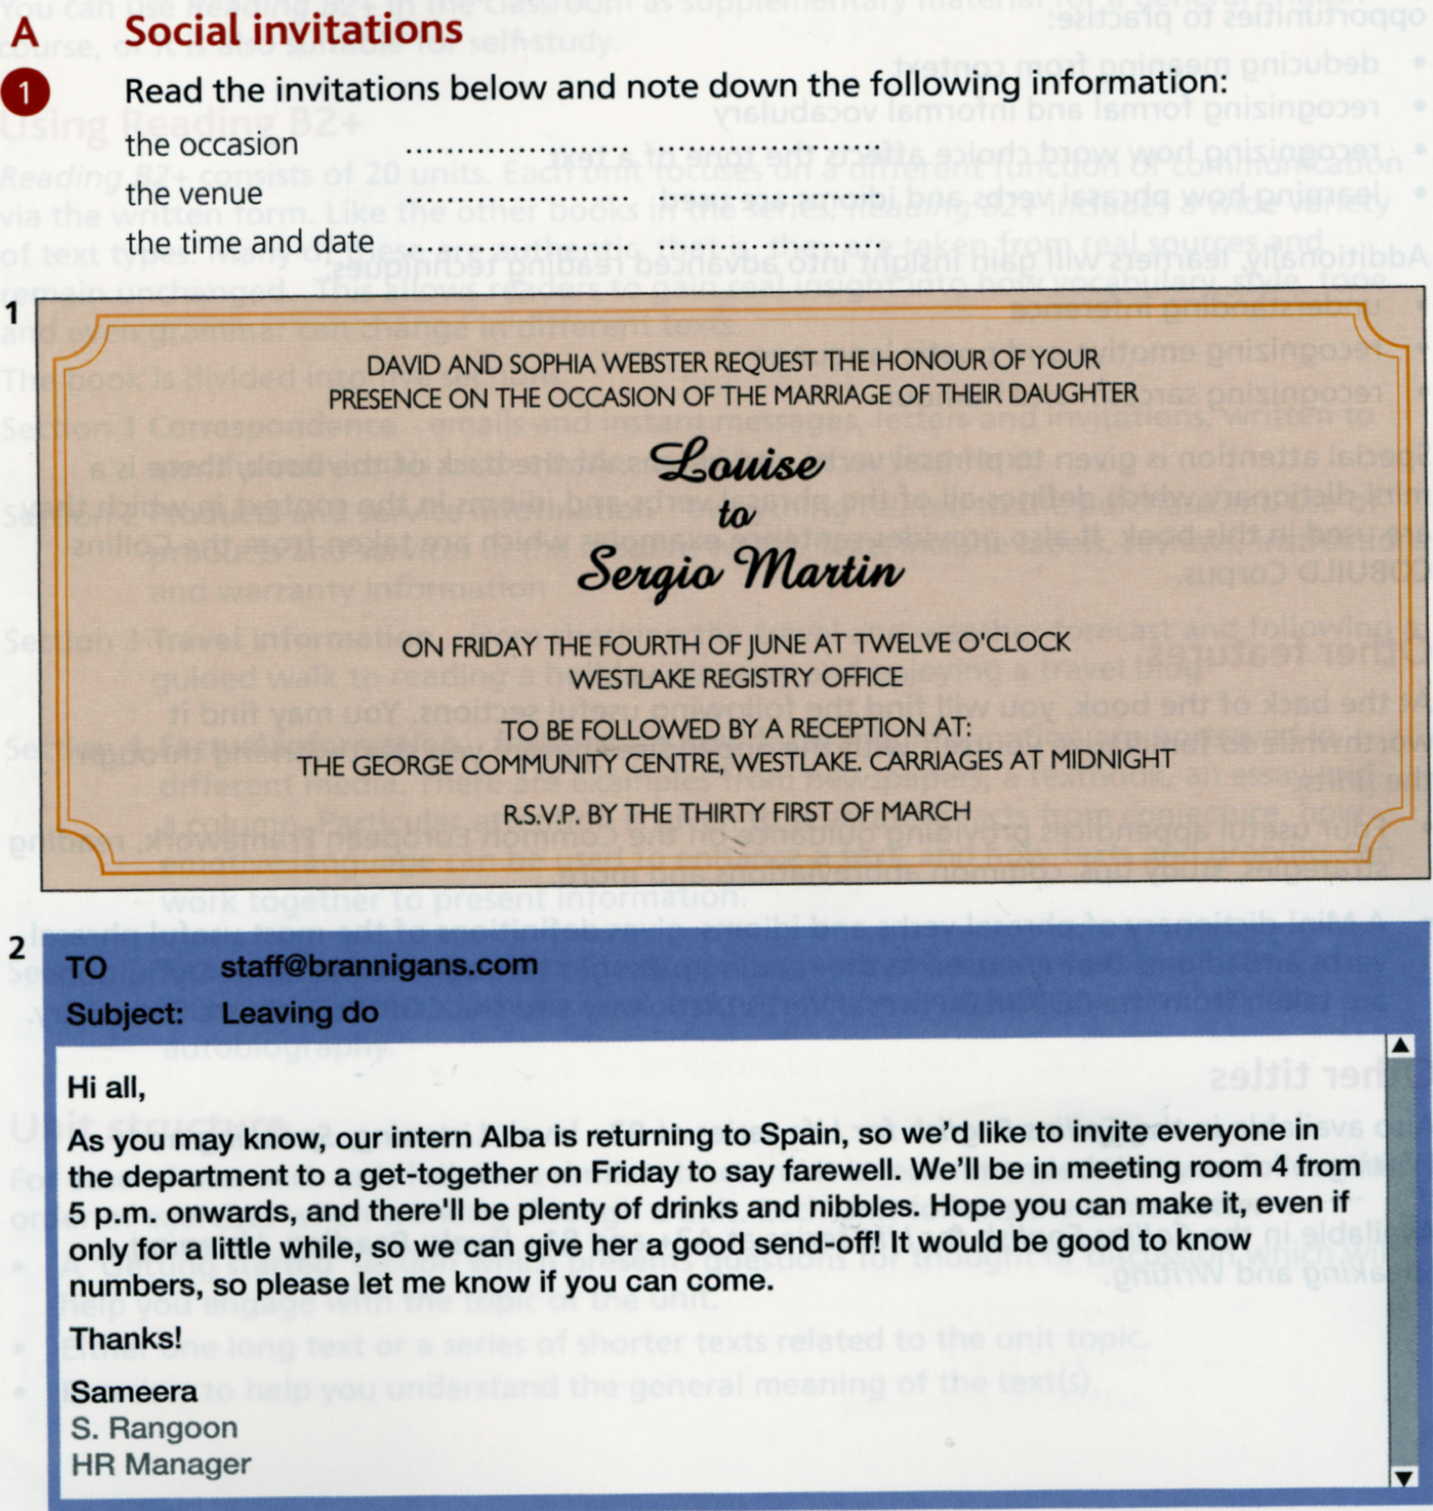

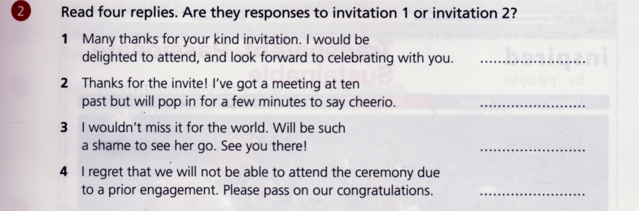

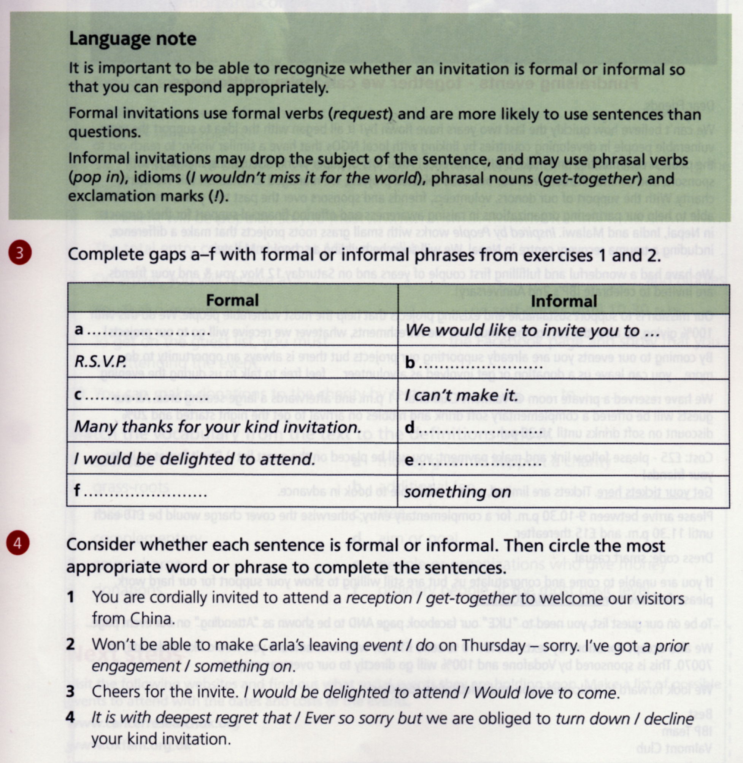

Jobs – adapter from Natural English Intermediate

Match jobs with their definitions
judges politicians lawyers accountants civil servants surgeons spies fashion models nurses professional sportsmen/women

___________________________________________ give secret information to other countries
___________________________________________ look after people in hospital
___________________________________________ operate on people
___________________________________________ decide what to do with criminals
___________________________________________ display clothes by wearing them
___________________________________________ check company’s/individuals’ finances
___________________________________________ earn their living from doing a sport
___________________________________________ are elected by people
___________________________________________ advise and represent people in court
___________________________________________ work in government departments

Do you know anyone who:
works freelance? / is training to be a doctor or a nurse? / is looking for a job? /works for a multinational company? / runs their own business? / has recently given up their job? /
has a job that requires a lot of traveling?

