Lesson 2 29th September 2014

The most popular pilgrimage destinations in Europe
(Adapted from http://religioustravelplanningguide.com)

Every year millions of people travel to see the Vatican. But Rome is not the only destination for religious tourism. Dozens of religiously significant cities and sacred shrines dot the vast and ancient landscape of Europe.
The following list spotlights some of the most visited holy places on the continent:
1. Fatima, Portugal
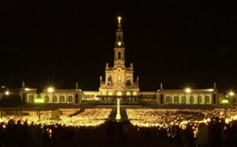
Chapel of the Apparitions
The Chapel of the Apparitions is built on the site of a Marian apparition that appeared before three peasant children in 1917. Every year since then on the anniversaries of the apparitions, May 13 and Oct. 13, the streets of Fatima swell with thousands of pilgrims who make their way to the holy site. Fatima (88 miles north of Lisbon) is home to dozens of imposing churches and monuments. Shops selling religious souvenirs, hostels and hotels can be found throughout the city.
2. Camino de Santiago, Spain
One of the oldest pilgrimage routes in the world runs through Northern Spain, terminating at the cathedral of Santiago de Compostela. This is the burial site of St. James, whose remains were transported from Jerusalem to Spain by boat. Pilgrimages to the area haven’t ceased since medieval times, and the route has enjoyed revived popularity since the 1980s. Traveling pilgrims can expect simple accommodations along the Camino de Santiago, or Way of St. James. Monasteries provide hostels for travelers and ask for small monetary donations in return. Pilgrims should be aware that a special Credencial, or religious passport, is required to stay at a monastic hostel.
3. Lourdes, France
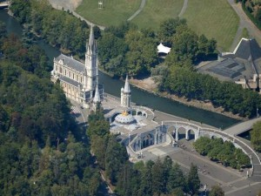
Lourdes
The largest pilgrimage site in France is Lourdes, which takes in some five million pilgrims a year. Lourdes gains significance from the apparitions of Our Lady of Lourdes and is a site of numerous miraculous healings. The stream unearthed by Bernadette Soubirous in 1858 is believed to have special properties that heal the ailments of sick people. Tourists stay in one of 270 hotels in the city in order to visit the Sanctuary of Lourdes (commonly called the Domain). The Domain includes the Grotto where pilgrims can take Lourdes water from taps.
4. Czestochowa, Poland
Poland has a Christian history more than 1,000 years old, and during that time the city of Czestochowa has gone through periods of enemy invasions and occupation. The shrine to the Black Madonna in Jasna Gora Monastery, attracting more than four million visitors a year, symbolizes the Poles’ determination to preserve their heritage. The painting of the Black Madonna has been the subject of miracles including bleeding after being struck with a sword during a Hussite attack in 1430. The 800-year-old buildings around the monastery bustle with tourist commerce.
5. Medugorje, Bosnia and Herzegovina
Apparitions of Mary have appeared before six children since 1981 in this Adriatic town and made the town a popular pilgrimage destination. The site annually attracts one million people, some of whom have witnessed visions in the sky including hearts and crosses around the sun. This once tumultuous region now has enjoyed an economic boom, thanks in part to religious tourism. More than 1,000 hotel and hostel beds are available.
6. Assisi, Italy
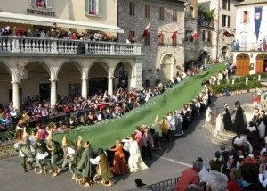
Festival Calendimaggio, Assisi
Assisi, an Umbrian hill town north of Rome, is most noted for being the birthplace of St. Francis. His influence is remembered in the Basilica of San Francesco of Assisi, which has been named as a World Heritage Site. This is just one of eight historic churches in the area. Two castles dominate the town, both built in the Middle Ages. In early May the Festival Calendimaggio re-enacts medieval life with games, processions, dances, flag waving and theatrical performances.
—By Karol Slowikowski

Holiday vocabulary
(Adapted from Natural English Intermediate)

