Lesson 6 6 November 2014

- Possessive ‘s
- Read the sentences
- Krzysztof’s house is a castle.
- Mathew’s hobby is photography.
- Sylwia’s smile is beautiful.
- My husband’s name is Robert.
- I’m going to my friend’s wedding this weekend.
- I’m going to my friends’ wedding this weekend.

- Weather
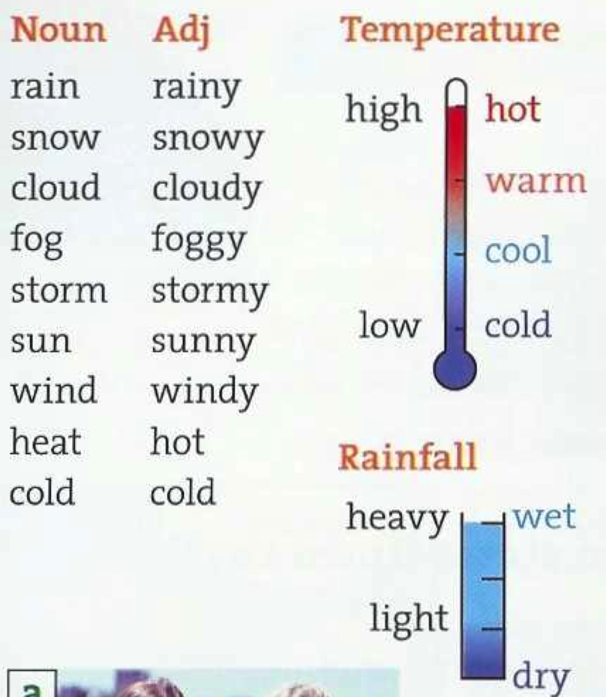

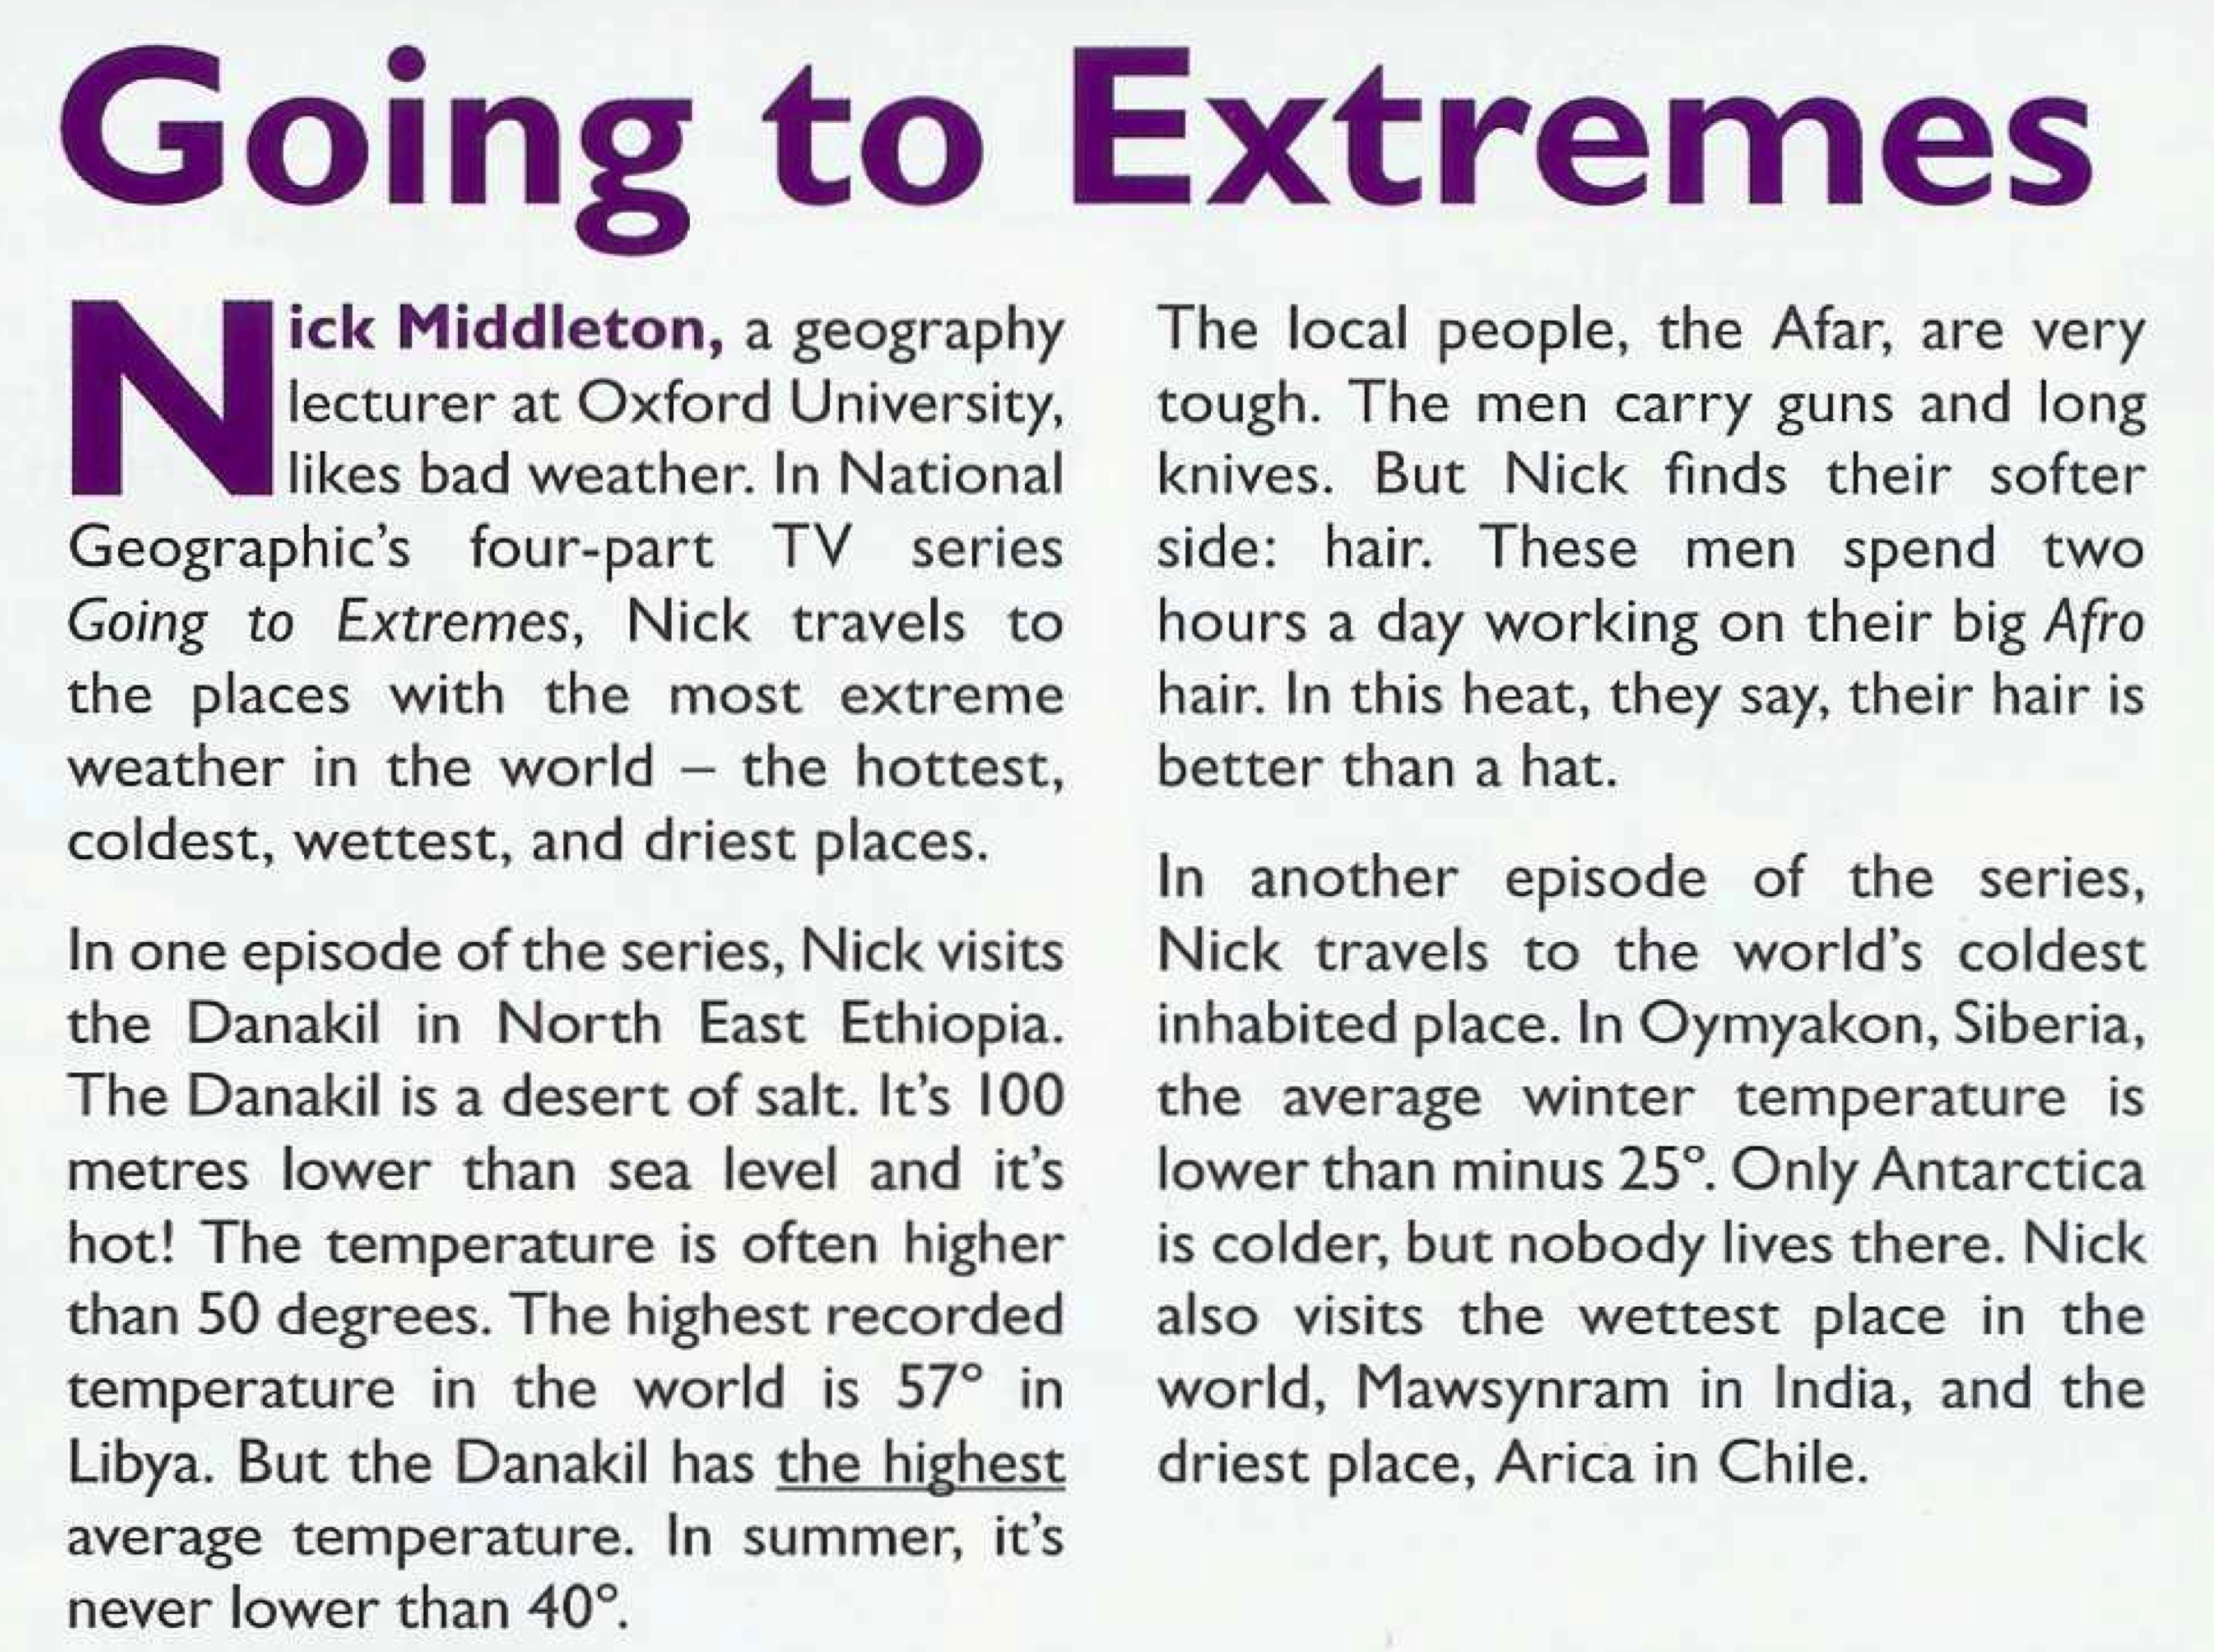

- Answer the questions to the text
- What’s the highest recorded temperature in the world?
- Which has a higher average temperature, the Danakin or Libya?
- What’s the lowest summer temperature in Danakil?
- What’s the average winter temperature in Oymyakon?
- Which is colder, Siberia or Antarctica?

3. Adjectives – big – bigger the biggest
c) Complete the rules
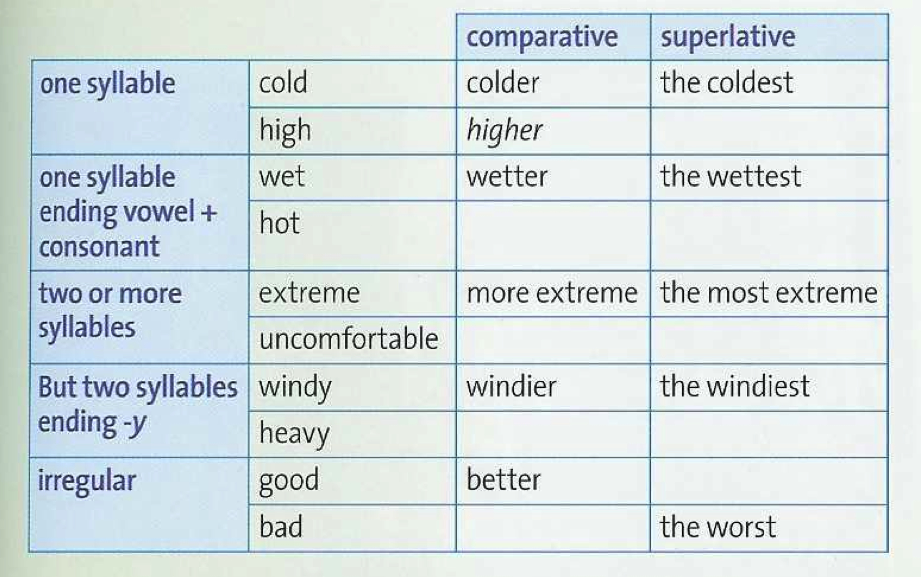

- Listen and complete the sentences about the weather in London and Sydney
- The rain is heavier in _________________ .
- _________________ is cloudier.
- _________________ is sunnier and hotter.
- In Sydney, the most uncomfortable months are _________________ and _________________.
- When Alan arrived in London, the temperature was _________________.

