Lesson 9 27 November 2014

Traveling and transport

adapted from: http://free-online-english.com
- Can you name the vehicles on the pictures?
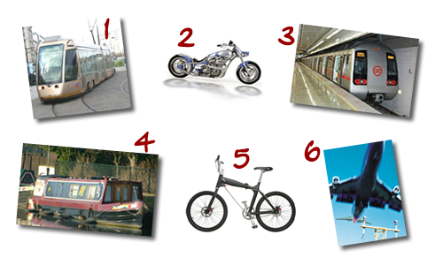

2. Listening
Are the following sentences true or false?
1. Mei thinks the best way to travel around Beijing is by motorbike.
2. Mei likes travelling by bus.
3. It takes Mei half an hour to get to work.
4. The roads in Cairo are very busy.
5. Fuad goes to college by metro.
6. Buses in Cairo are expensive.
7. Sandra goes to university by bike.
8. Bicycles are the best way to go shopping.
8. Sandra often travels by boat.

3. Adjectives
All these adjectives were in the listening. Which would you use to describe the transport? Can you add any more?
large crowded comfortable slow busy quick popular expensive

Rules on the road
(adapted from English Result Pre-Intermediate)
4. Are these rules true for Poland? If not, correct them.
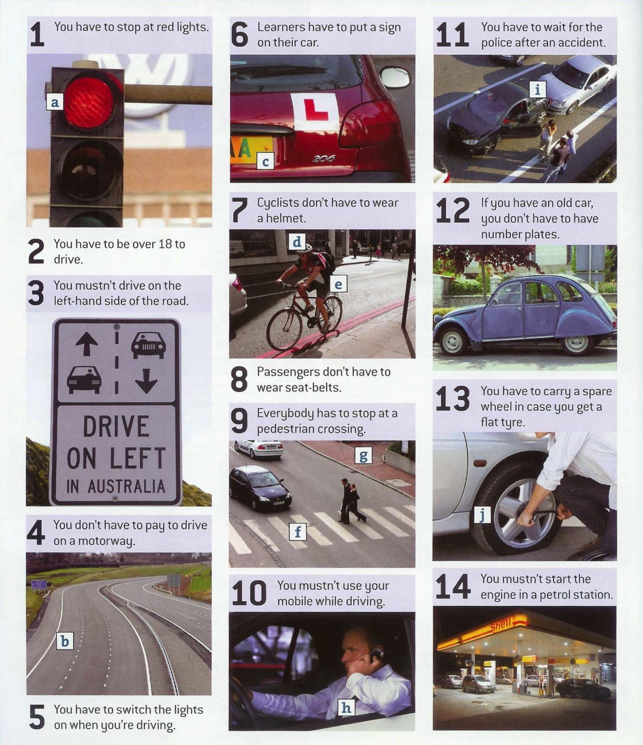

5. Match these words with things a-j on the photos
- accident _____

- cyclist _____
- helmet _____
- number plates _____
- motorway _____

- pavement _____
- pedestrian crossing _____
- seat belt _____
- traffic lights _____
- tyre _____

