Lesson 6 3 November 2014

Shopping

(Adapted from Natural English Intermediate)

- Are these statements true or false? Correct them if they are false

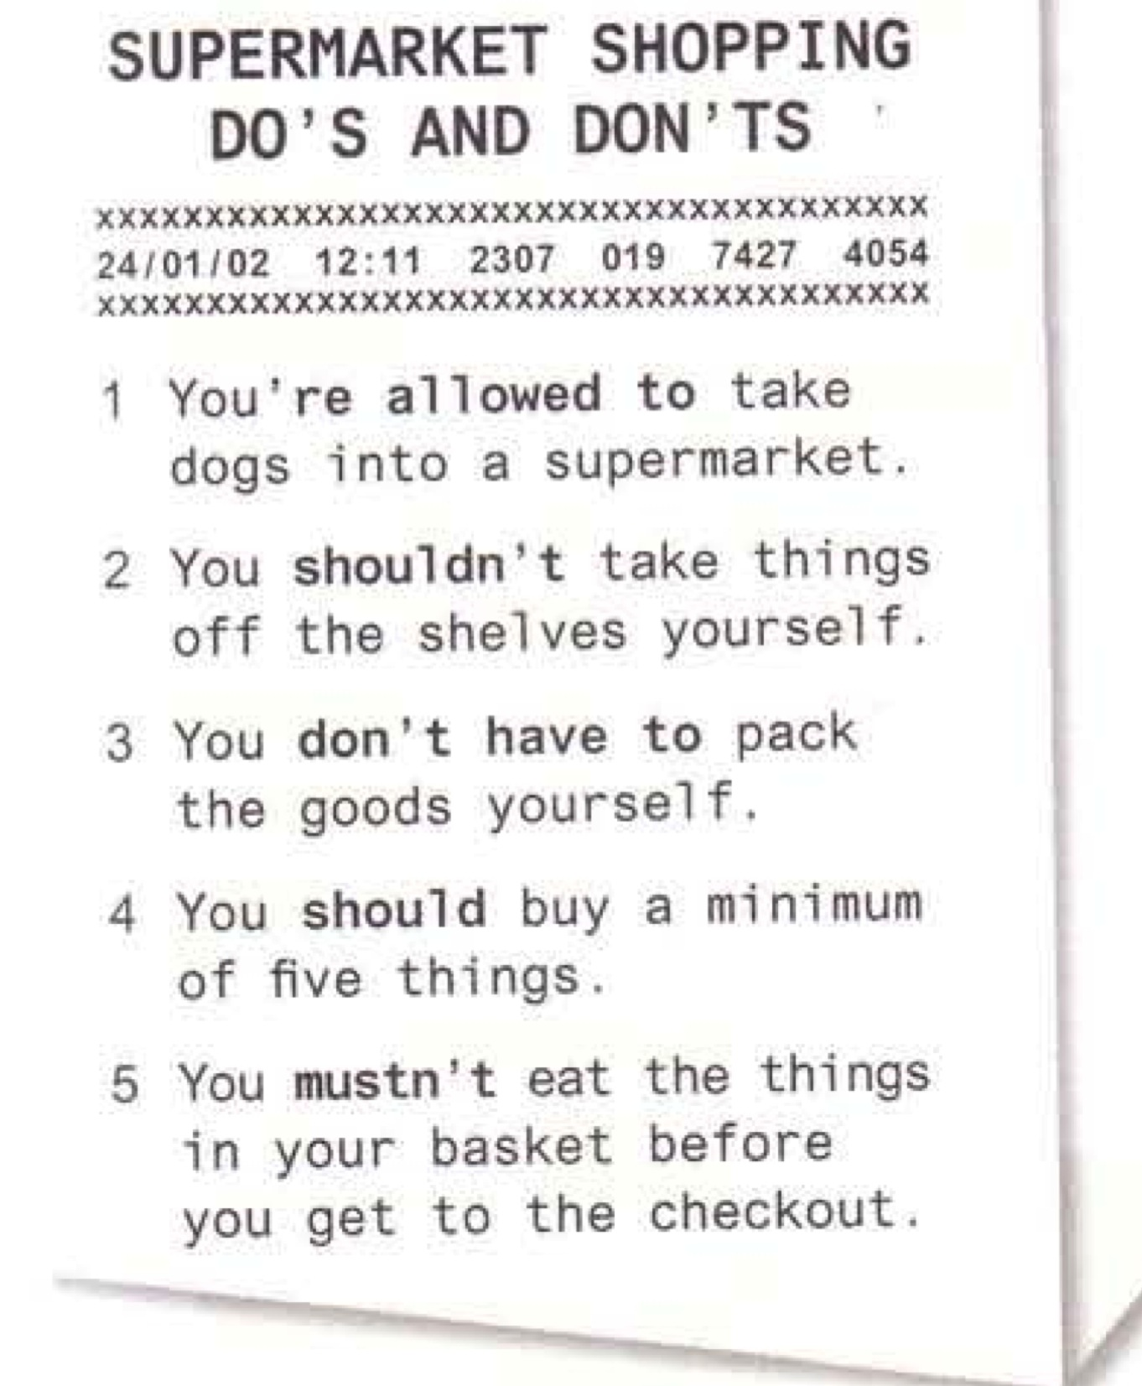 | 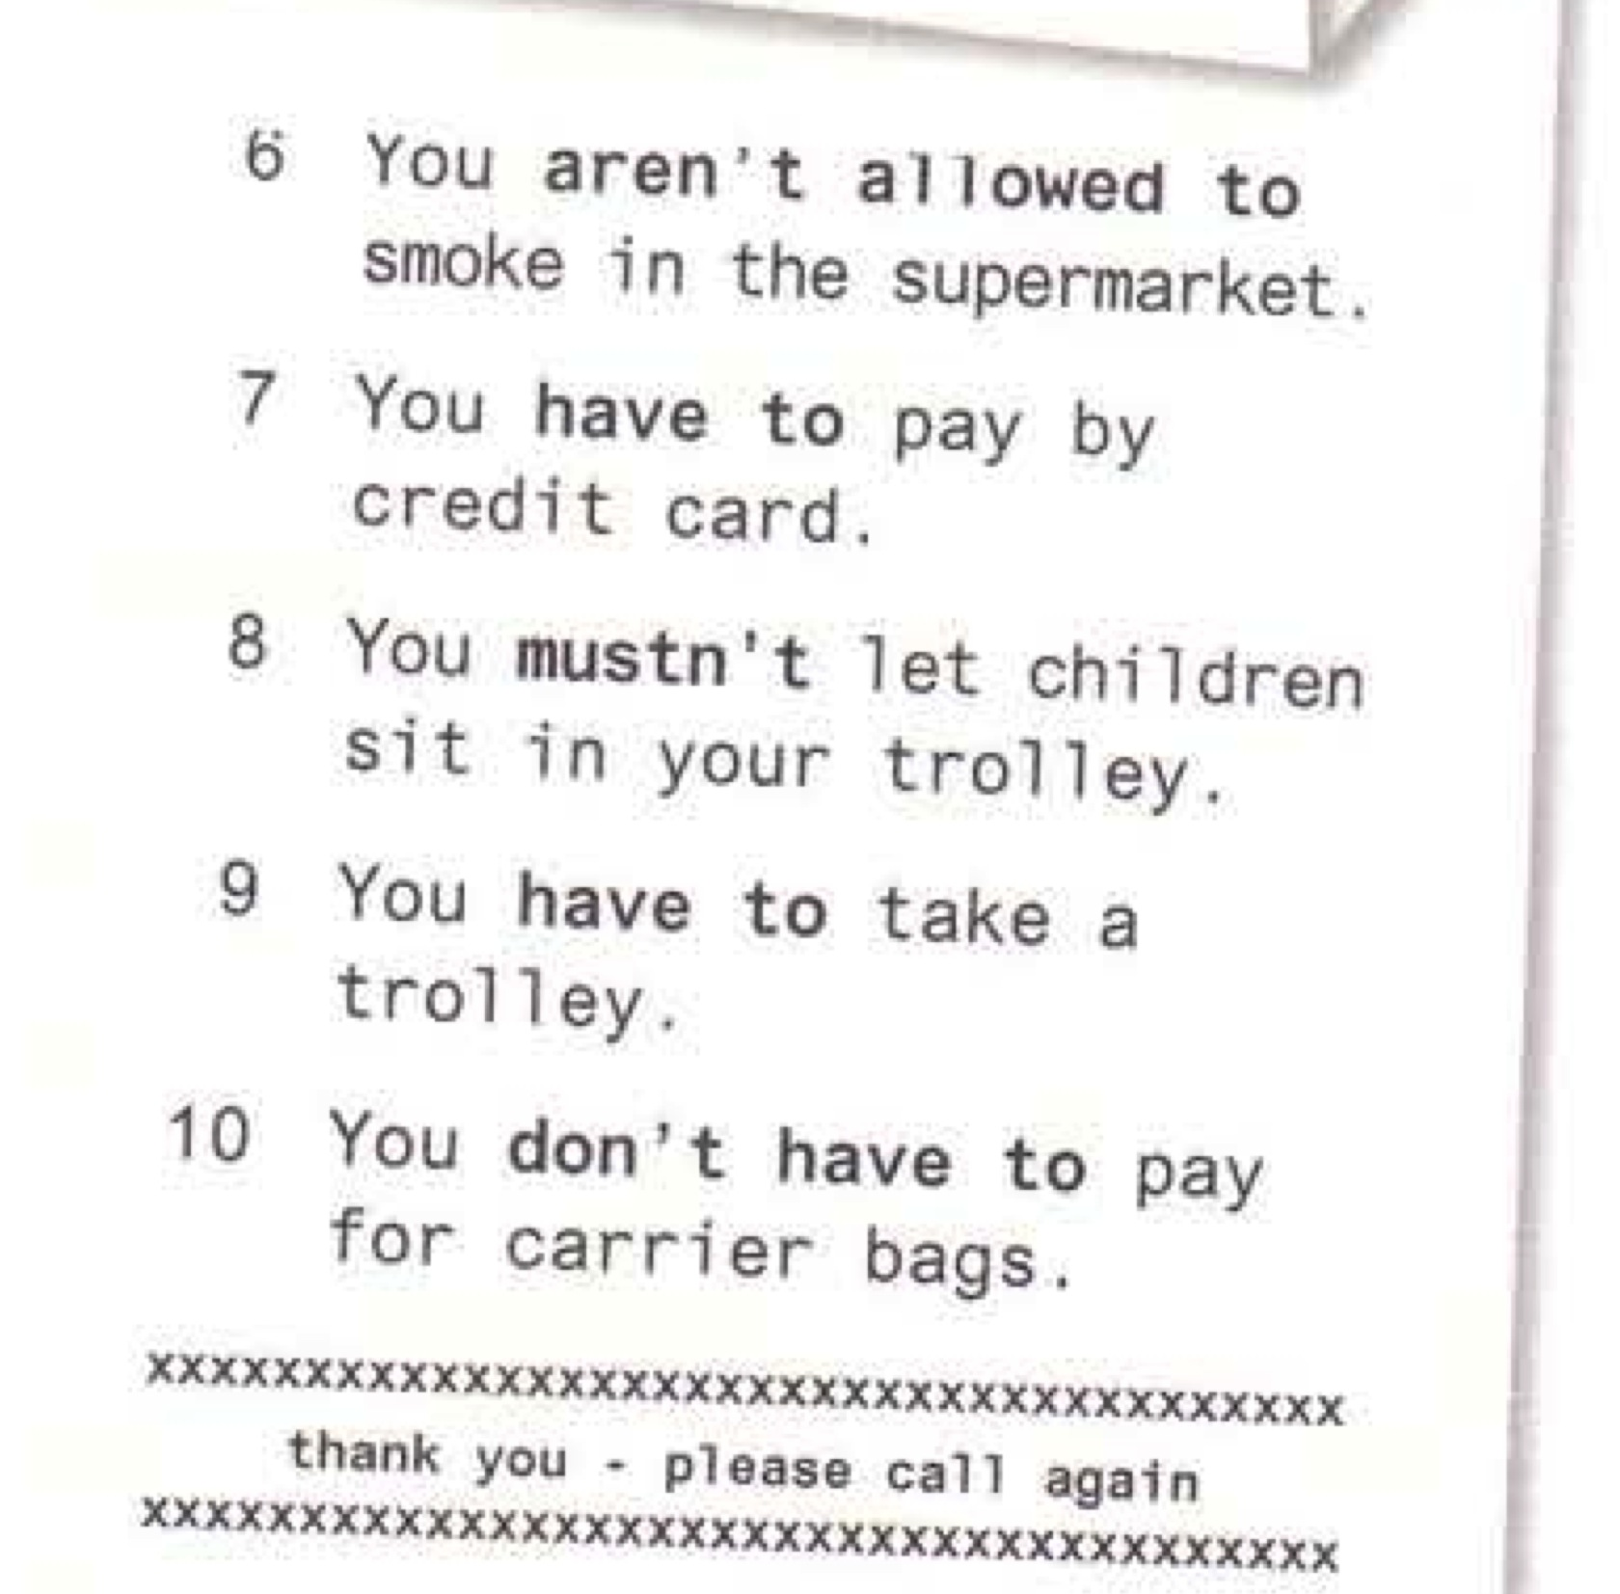

Harrods
(Adapted from http://www.aviewoncities.com)
Harrods is one of the world's most famous stores and one of London's tourist attractions thanks to the wide assortment of luxury goods that are on display in a magnificently decorated building.

The company's motto is Omnia, Omnibus, Ubique (Everything, for everyone, everywhere). Harrods used to be known as the store where anything you could think of was for sale. You can purchase anything from historic eighteenth-century dinner plates or exquisite caviar to giant teddy bears.

It is best to take your time for a visit to the large store, which covers an area of about 80,000 sq m on seven floors. Floor plans are available near the entrances.

One of the most beautiful departments of the store is the magnificent Food Hall on the lower floor, decorated with tiles created by artist Williams James Neatby. Other impressive departments include the Egyptian Halls and the Crystal Rooms. Also the central escalator, decorated with Egyptian motives, is interesting. And don't forget to visit the toy department - the city's best - where you'll find enormous stuffed animals.

Tips On Bargaining In The Middle East

(Adapted from http://www.middleeastbackpacking.com)

Bargaining is an integral part of most Middle Eastern cultures and something that can be problematic for travelers who are not used to it.
The key to being good at bargaining is understanding its purpose – it is not about money or trying to maximize profit as many think – but more about building relationships. These are some ways you can learn the art of bargaining to save money and see more when traveling in the Middle East.
- Browse Around First – You’ll have a better idea of what the costs of a particular item are if you compare the prices in a number of shops. This way you can choose the right seller to bargain with.
- Hide Your Interest – No matter how interested you might be in buying something, do your best to keep your feelings to yourself. If you show that your really want to buy something, it’s hard to bargain.
- Engage In Conversation – Don’t be shy. You’ll learn a bit about the shopkeeper and you are much more likely to walk away with a good price.
- Know The Local Discount – In some countries a 25% discount means you’ve struck a good deal while in other places that number can be as high at 50%. Learn the common prices and bargaining discounts from local people, online research, or your hostel or hotel owner.
- Don’t Feel Guilty – Many shopkeepers may try and use guilt to get a higher price from you. You probably aren’t rich and even if you were, you should get a fair price.
- Learn The Local Customs – Avoid taboos or gestures that might be harmless in your culture but offensive locally.
- You Can Always Say No And Walk Out – That is your most powerful bargaining tool.
You shouldn’t settle on a price you aren’t comfortable with and you’ll likely find many similar (or better) items at many nearby shops. Just keep looking and you’ll come across a shop where you find something you like, get a good conversation, and save some money too.

